Workshop on Data Integration: Realising the Potential of Statistical and Geospatial Data - Belgrade, Serbia, on 21-23 May 2019

Title: Statistical architecture and data integration

Janusz Dygaszewicz
Director
ICT Systems, Geostatistics and Census Department
Anna Długosz
Deputy Director
ICT Systems, Geostatistics and Census Department

Abstract:
A significant matter in statistical production is data integration. There is a necessity of various statistical data and integration of statistical and geospatial data. A crucial issue for data integration is implementing a process approach, according to the GSBPM, departure from a stove-pipe production, based on data silos and building a modern reference architecture supporting statistical process. Nowadays we start explicitly reaching the vast information from administrative, as well as non-administrative sources, social network, data collection based on sensors, motion sensors or GPS technology. Data silos are a hindrance to data integrity and a barrier to production efficiency.
The source of problems in this area is the lack of a coherent approach to modelling and designing IT solutions supporting statistical production, including data integration. A modern reference architecture should regard that every data has a geospatial aspect and geospatial data integration is evolving day by day and gets a more significant role in information production. Focusing attention on data, including geospatial information and geospatial data) and workflows require a coherent approach to modelling and designing IT solutions supporting statistical production.
Another necessary assumption for data integration is metadata. Metadata are used for describing the data at each stage of their processing and facilitating the integration of data.
Key words: data integration; geospatial data; a reference architecture framework; metadata; repositories
- Introduction
Data integration involves combining data from different sources and enables a unified view. Integration of data is nothing new. We deal with it. We integrate statistical data with geospatial data, collected data from responders and administrative data.
Our implementation of the GSBPM - Model of the Statistical Production Process (MSSP) - has some additional sub-processes.

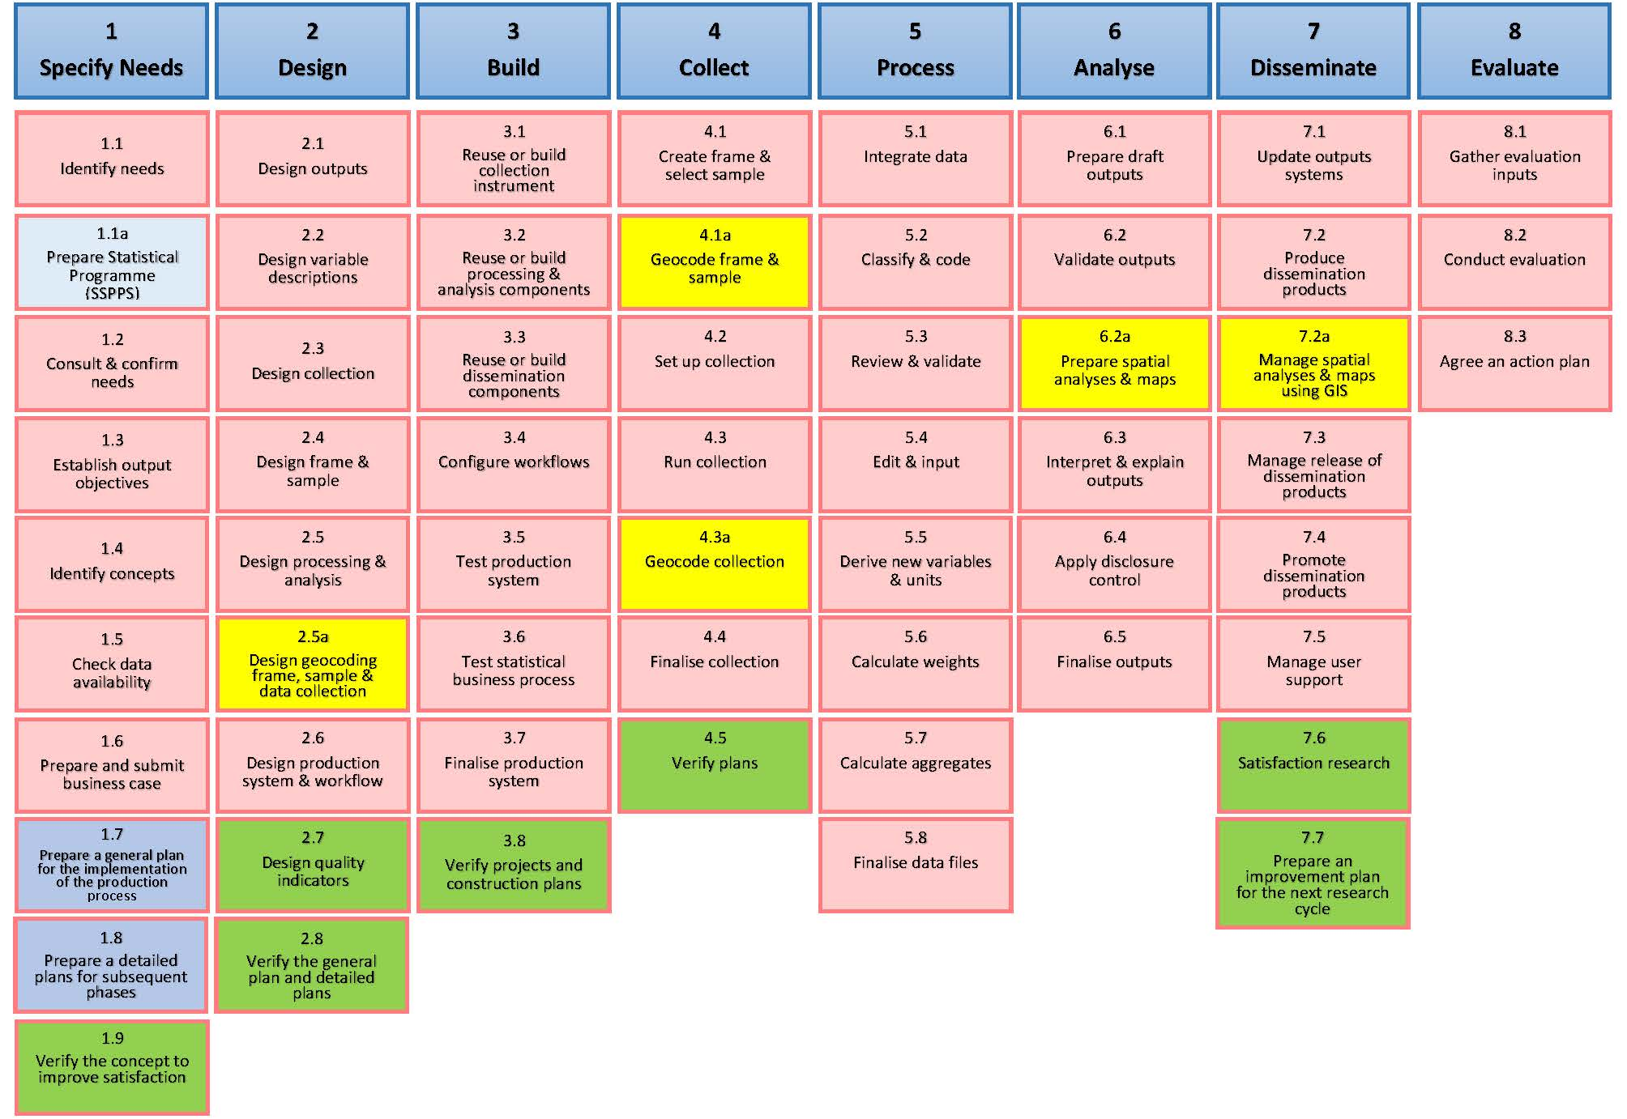

These additional sub-processes are mainly connected with geospatial information. We are very focused on geospatial data which are omitted in the traditional GSBPM model. The possibility to integrate statistical data with geospatial information is very crucial in our activity.
But we see a need for improving the efficiency for the integration process, its quality. Integration data is connected directly with collecting data, transformation and cleaning them. It is obvious that there are needed some activity before integration of data. And these sub-processes, their efficiency and quality impact of the efficiency and quality of integrated data. So we can’t think only about one process a reference architecture framework “Integrate data” to improve efficiency of the integration process and quality of integrated data.
The GSBPM includes all processes needed to produce statistics . But an important issue is to exteriorize main phases, which have the most impact on the outputs and reception of our products. These phases should be boosted initially. And we defined these phases as Collect, Process, Analyse and Disseminate.
The next move is to create (RAF) based on a process-oriented model of statistical production and create a performant metadata system.
In this way, you can improve the data processing performance, including data integration.

- Reference Architecture Framework (RAF)
An important issue in implementing a process approach, according to the GSBPM, is the departure from a stove-pipe production, based on data silos. Nowadays we start explicitly reaching the vast information from administrative, as well as non-administrative sources, social network, data collection based on sensors, motion sensors or GPS technology. Data silos are a hindrance to data integrity and a barrier to production efficiency.
The stove-pipe statistical production impedes productivity, conduce to redundancies and duplication of work. This issue is becoming particularly significant now, in the context of slimmer measures financial resources for statistical surveys and striving for reducing the burden of respondents. The source of problems in this area is the lack of a coherent approach to modelling and designing IT solutions supporting statistical production.
Complete implementation of the GSBPM, a departure from a stove-pipe statistical production, focusing attention on data and workflows requires a coherent approach to modelling and designing IT solutions supporting statistical surveys.
From the MSSP phases, we define four phases as the actual production cycle. These phases are: Collect, Process, Analyse and Disseminate.
- Data repositories
The critical elements of the solution are "Data Repositories". This approach allows generalization of the description of the functions of database objects in the statistical production process storing and providing statistical data for subsequent "states", resulting from the advancement of their processing in subsequent phases of the statistical production process.

  - a registry data repository (SJS)
  - a raw data repository (SDS)
  - an operational data repository (SDO)
  - an analysis data repository (SDA)
  - a geospatial data repository (SDG)
  - a publication data repository (SDP)
  - a metadata repository.

- The phase collect
In this phase, data is collected and saved in the Raw Data Repository (SDS) to make them available for further processing in a production environment. Data collection is preceded by the determination of the data collection method, the creation of a list for a survey based on the content of the Registry Data Repository (SJS) and the selection of a random sample in the case of a representative survey. An additional two geocoding sub-processes, both the list itself and/or the sample as well as the unit data, use the contents of the Geospatial Data Repository (SDG). Also, an additional sub-process “Verification of plans” should be performed to assess the quality and take possible corrective actions. Positive verification of plans, conducting geocoding of collected unit data and finalize the phase allows going to the phase” Process”.
The main effect of the phase is a set of unit data, correctly verified and collected in the Raw Data Repository (SDS). It should be emphasized that the phase “Collect” is the first of the four phases of the actual production cycle. It is crucial from completeness and quality of input data necessary to calculate final products expected by public statistics users. For this reason, the implementation of each of the sub-processes should be consistent with the assumed qualitative indicators, located in the Metadata Repository. After completing the sub-process, the effects of its implementation should be described with appropriate metadata and stored in the Metadata Repository. Achieved values of qualitative indicators should decide on admission to the next phase of the production cycle or starting procedures for improving the quality of collected data.
- The phase Process
In this phase, the data are processed (transformed) to prepare them for statistical analyses. The unit data made in Phase 4 stored in the Raw Data Repository (SDS) is subject to transformation following pre-designed rules that are stored in the Metadata Repository. Data after integration with the statistical system are subject to statistical classification and coding under established dictionaries and classifiers (5.2). Then the data is reviewed for verification and validation (5.3), followed by their final transformation (5.4) to a set of statistical unit data. At the same time, it should be possible to calculate new complex variables and statistical units and to supplement missing data (imputation), as well as final anonymisation or pseudonymisation of identifiable unit data. In the case of sample surveys based on a random sample, weights are determined (5.6), the results are elaborated on the whole population studied, and their necessary calibration is carried out and the essential aggregates calculated. After positive verification of qualitative indicators for this phase, final data sets are created, which should be loaded into the Operational Data Repository (SDO). For statistical surveys carried out regularly, this phase is carried out each time. Sub-processes of this phase may take place as many times as necessary (with the possible exclusion of sub-process 5.6 ("Calculation of Weights"), which is specific only for representative surveys). Phase 5 "Process" and the next Phase 6 "Analyse" are usually implemented sequentially.
In some cases, however, it is allowed to implement both phases iteratively or in parallel. This is since during the analytical work, and there may be an urgent need to provide additional data, which may mean that another processing cycle will be needed for all or part of the collected data, which may also lead to a restart of Phase 4 "Collect". It is allowed that the "Process" and "Analyse" phases may start before the end of the "Collect" phase, which in justified cases is necessary for the preparation of preliminary results. Making initial results available is very important for some users of statistical data, expecting quick statistics to make initial management or investment decisions. All effects of the sub-processes of this phase should be described in the metadata stored in the Metadata Repository. It is particularly important to include the meta information regarding the quality of data placed in the SDO, the degree of their processing, compliance of definitions of concepts and classification, the level of missing data (imputation) and removal of unnecessary repetitions (deduplication) and the precision of the final results.
- The phase Analyse
In the sixth phase, the analytical statistical products needed to develop the resulting statistical information or intended for direct sharing are produced and thoroughly checked. The phase also includes the preparation of necessary meta-information and additional explanatory information in the form of comments, descriptions or methodological notes accompanying statistical publications. Before sharing the results, make sure that the analytical products are compatible with the resultant data and that they meet the needs of users. This phase begins with the downloading of data from the Operational Data Repository (SDO) and preparation of preliminary results (sub-process 6.1), and then their validation following the rules stored in the Metadata Repository (6.2). The special attention should be paid to the issue of spatial analysis. Spatial data requires a separate treatment due to the necessity of using GIS tools, models adequate for spatial data, geocoding methods and spatial analyses. Therefore, in the proposed MPPS model, a separate sub-process devoted to this class of data was created. Phase 6 has been modified by adding sub-process 6.2a "Development of spatial analyses and maps", which should be located between sub-processes 6.2 and 6.3.
Before the final verification of the resulting data, the fundamental spatial analyses should be carried out and prepared for the presentation on the maps. The resulting data supplemented with spatial analyses should be subject to final review and explanation (6.3). Such prepared and checked data before their publication requirements, under the Act on Statistics, to check for statistical confidentiality, so that it is not possible to disclose the identity of subjects participating in the statistical survey.
- The phase Disseminate
This phase includes all activities related to rules and mechanisms of sharing (sub-process 7.1) and preparation of a group of products (7.2) to make them available (7.3) in various forms and forms, in multiple channels of sharing, both traditional and electronic. Because spatial analyzes and maps require a unique infrastructure adequate for GIS technology, the phase has been enriched with sub-process 7.2a. - "Managing spatial analyzes and maps using GIS". In connection with this supplement, I initiated the commencement of work related to the construction and implementation of the Geostatistics Portal, a new channel for sharing statistical data. This portal makes it possible to provide geostatistical data in the form:
- of electronic publication of spatial analysis results, including mobile devices such as smartphone, tablet, etc.,
- cartograms in digital channels.
The management activities for data sharing, through the existence of a sub-process (7.4), support users in the use of statistical products made available by official statistics. This support takes place through proper communication and promotion activities. An additional sub-process of satisfaction survey (7.6) was created to facilitate the assessment of whether and to what extent the designed and built statistical production process produces products that meet the expectations of final recipients. The acquired knowledge, following the TQM methodology, is crucial for improving satisfaction in the next cycle of the research and allows to assess the relevance of identifying the needs of users in Phase 1 and, if necessary, preparing the essential improvement plan (7.7). All effects of the sub-processes of this phase that are important for the quality of the products being made available should be described in the metadata stored in the Statistical Metadata Formation. It is particularly important to include the metadata about the quality of products placed in the SDP in the Metadata Repository, the degree of their compliance with the designed sets of publication products and the degree of consumer satisfaction of the resulting statistical information.
- The metadata system
Data sets that are not provided with the appropriate metadata have a much lower value, and may even become completely useless. Data Integration is associated with the ability to handle all types of data. In a quest to build more efficient processes, one of our top priorities today is to create and consume rich and powerful metadata, which is basically “data about data.” In addition to the metadata describing the set, the data contained therein should be remembered about other metadata, for example illustrating data processing, including data integrating. There are four main types of metadata: business, structures, exchange and conceptional (according to GSIM). Each plays a large part in the building of data integration components.
But the value of metadata is unsung.
The statistical production process should be based on a well-designed metadata system. It helps to improve the quality and efficiency of a process, quality of statistical products.
Without the ability to manage metadata efficiently we lose time and productivity.

