INTEGRATING GEOSPATIAL DATA WITH ADMINISTRATIVE RECORDS TO PRODUCE OFFICIAL STATISTICS
Nyambayar Zorigt
Specialist of the Public Relations Division, Administrative Department,
Oyunjargal Ganbaatar Programmer Information Technology Department, National Statistical Office of Mongolia
nyambayar@nso.mn
oyunjargal_g@nso.mn

Abstract
This paper aims to introduce about the development of geospatial database for the utilization and production of statistical products at the National Statistical Office (NSO) of Mongolia. In preparation for the 2020 Population and Housing Census, which is planned to be conducted with a multi-modal approach, NSO Mongolia has planned series of activities that involve development and enhancement of geospatial statistical framework.
INTRODUCTION
Geography
Mongolia is an eastern hemisphere Asian country located between 41° 35" N - 52° 08" N latitude and 87° 44" E – 119° 55" E longitude. It extends for 2,392 kilometers from west to east and 1,259 kilometers from north to south and has a territory of 1,564,116 square kilometers. It is the 19th largest country in the world by territory and is the second largest landlocked country after Kazakhstan. Mongolia neighbors with only two countries, Russia on the north by 3,543 kilometers and China on the east, south and west by 4,710 kilometers. The next closest neighboring country Kazakhstan is only 38 km away to the west.
The country is situated on the Mongolian plateau with an average elevation of 1580 meters above sea level, mainly consisting of grassland and desert plains including Gobi Desert and mountainous areas including Altai Mountains. It has an extreme continental climate and four seasons. Winter is relatively long and cold with occasional snow storms and blizzards where the temperature reaches up to -40°C, whereas summer is mostly sunny and dry with temperatures ranging from 20°C to 35°C.
Traditionally, it used to be considered in the Central Asian region by the UNESCO classification and now, according to the UN geoscheme, Mongolia is considered in the Eastern Asian region.
Administratively, Mongolia is divided into 22 provincial units including one capital city and 21 Aimags (provinces) which are put into five regions for geographic and socio-economic policy development. The 22 administrative units are further divided into 339 district level administrative units which are comprised of 1765 sub-district or first-level administrative units.

Figure 1. Administrative Divisions of Mongolia
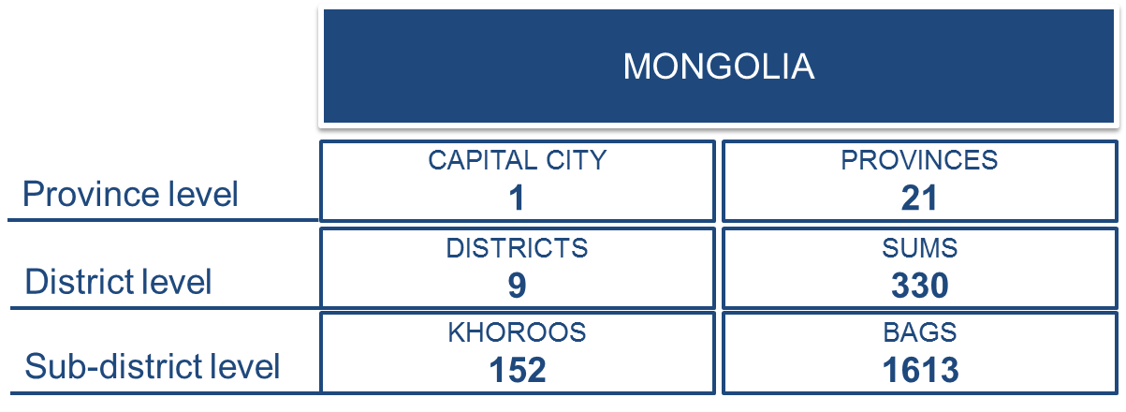
Statistical information in Mongolia
It is inevitable that life exists in dimensions of time and space. Us, the human society is an integral part of it and at any given situation, any incident of our existence occupies certain geographic aspects and time intervals. The science of statistics has developed well enough to capture data regarding any incident in relation to time and location. Nowadays, in all sectors of government administration and services as well as private industries, data is created and stored in mass. Effective utilization of modern technological advancements and geospatial data, such as, geographic information system incorporated with socio-economic statistical dynamics can be powerful tools to analyze any given problems of our society and identify comprehensive solutions.
As the country’s central statistical organization, National Statistical Office (NSO) of Mongolia produced and disseminated over 430 indicators in 2016 compiled from various sources including censuses, sample surveys and administrative records. In accordance with the Law on Statistics of Mongolia, NSO Mongolia disseminates more than 346 indicators of official statistical information regarding 48 topics, including macroeconomic statistics, population and social statistics, industry, science and technology statistics, legal statistics and environmental statistics.
Figure 2. Number of Official Statistical Information NSO Mongolia Releases
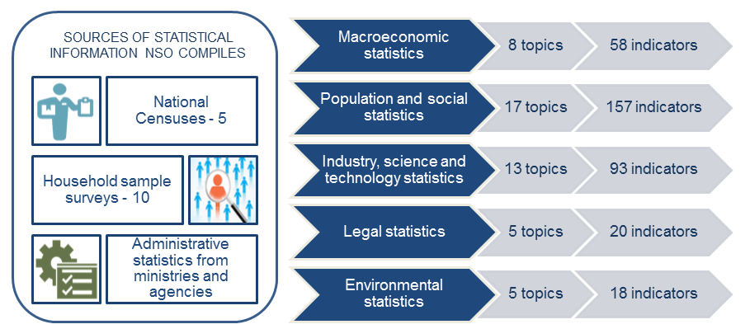
DEVELOPMENT OF GEOSPATIAL STATISTICAL FRAMEWORK AT NSO MONGOLIA
Geospatial database
Geographic information system (GIS) was first introduced at the NSO Mongolia for the 2010 Population and Housing Census and it was utilized for every stages of the census undertaking including planning, monitoring and most importantly for results dissemination and visualization. Before the 2010, geographic information in statistical undertaking mainly served as planning and monitoring tools in forms of roughly drawn basic cartography.
The development of GIS at the NSO Mongolia brought the inter-agency government collaboration to a new level. Changes in legal basis were carried out in regards to enabling the use of certain scale topographic and cadastral maps, which were otherwise considered as classified and not shared. In 2010, NSO Mongolia was able to use 1:200000 scale topographic maps for rural areas and 1:1000 scale cadastral maps in urban areas and centrally produced more than 2000 area maps for enumeration. Availability and use of existing maps and other information has been much improved since.
During the 2010 Population and Housing Census, geographic location or waypoints of each household was captured and digitized without the use of GPS devices, which was then considered as best practice and an important step towards establishing geospatial statistical database. Web-based GIS was developed and the census results were disseminated on an interactive web maps for the first time. National atlas based on the census results was also produced and widely disseminated.
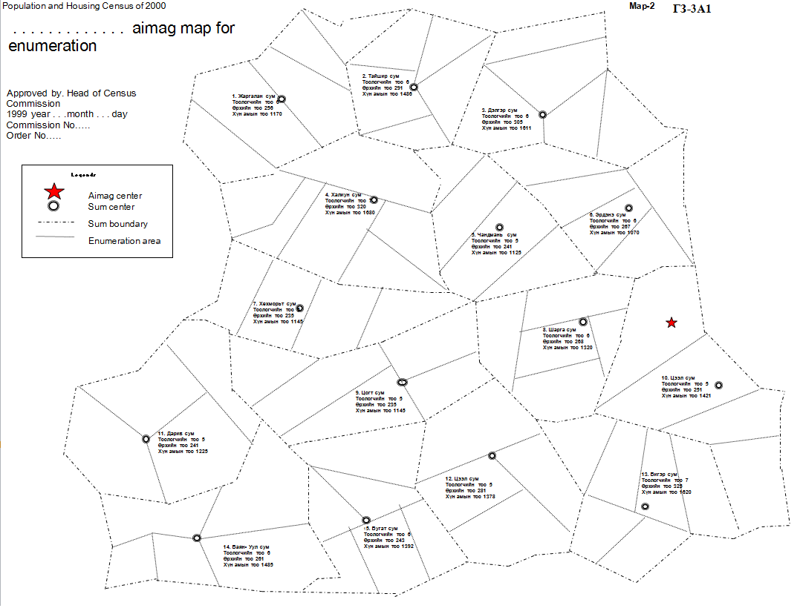
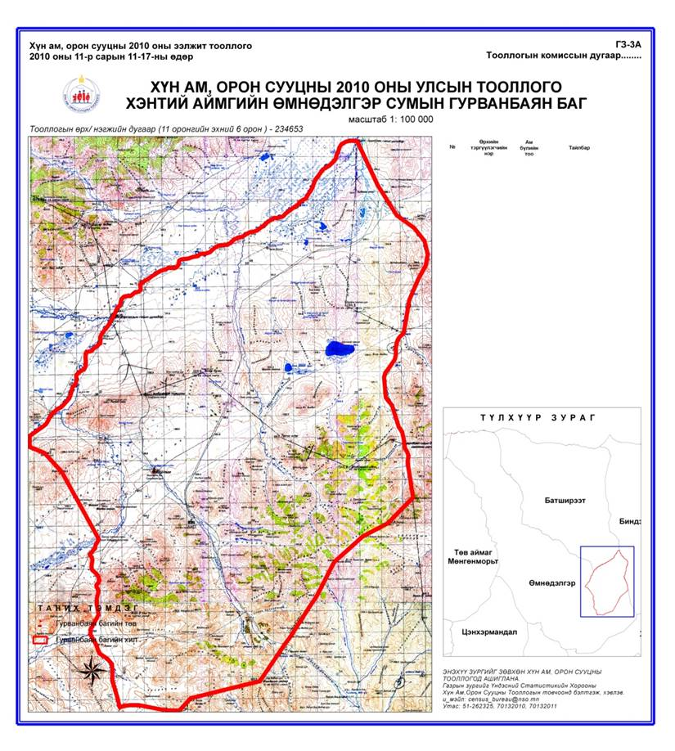
Figure 3. Manually drawn province map used during the 2000 census
VS. GIS generated census cartography used during the 2010 census
Following the 2010 Population and Housing Census, the GIS has been used extensively for national censuses, including the Business Establishments Census of 2010 and the Agricultural Census of 2011 as well as national surveys, such as Small scale mining survey for the same purposes.
Integrated statistical database
In 2015, midterm Population and Housing Census was conducted for the first time since the enactment of the Law on Population and Housing Census in 2008. It was the first ever register-based census approach for Mongolia and the outcomes have been quite satisfying. Based on existing local database of population and household register booklet recorded and kept at the sub-district or first level administrative units, real-time and online Population and Household Register Database was created. With great vision of incorporating many other administrative records database in the future, the Population and Household Register Database demonstrate important features, such as, household waypoint and current personal information match against the Civil Registration Database.
Integration of over 1700 sets of existing population and household register local database checked against more than 30 administrative records database, such as, civil registration, immigration, health, social security, social welfare and others involved voluminous amount of data matching and data cleaning. Additionally, it revealed serious underlying problems and identified areas of improvements.

Figure 4. Vision of Integrated Government Database
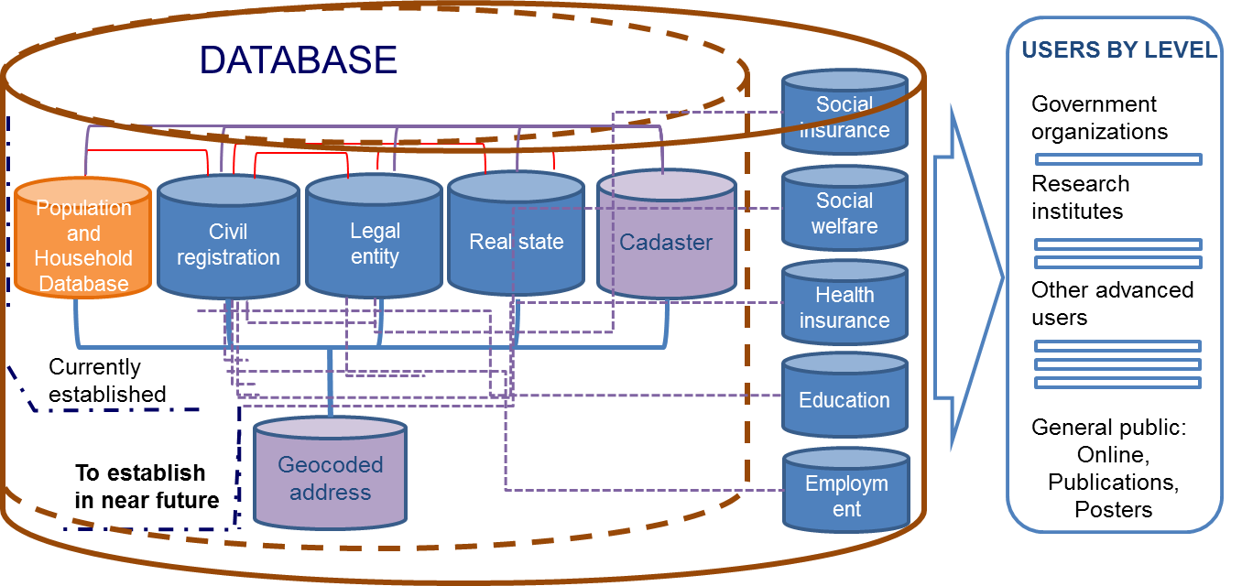
One of the major problems was inconsistency of standards and classifications for commonly used or main attributes. For instance, currently under discussion at the NSO is the issue of discrepancies between the administrative unit names and codes among the Civil Registration Database (administered by Civil Registration Authority) and the Population and Household Register Database (supervised by NSO and administered by local Governor’s Office). This specific type of discrepancies require minor to major changes to be made in more than 150 sub-district administrative units for their names and codes in either of the two databases. If a change is to be made in Civil Registration Database, it will also require changes to be made in the personal document of the subject affected by the administrative unit that calls for more dilemmas. This particular problem initially arose from incoherence between the procedures of government agencies and errors in applying standards and classifications that is believed to be common for other government agency databases as well. Therefore, NSO Mongolia is taking the lead role for aligning the standards and classifications used in databases and actively promoting the development of integrated government database. For this purpose, NSO Mongolia is undertaking the following activities:
- Carry out complete evaluation of government agency databases and identify methods of incorporation;
- Make amendments in the Law on Statistics /to enable NSO to access all databases established at government and private sectors for only statistical purposes upon safeguarding the privacy and confidentiality/;
- Improve the development of satellite databases such as health, education, social insurance, disability and others one by one and foster the linkage to the Population and Household Register Database;
- Develop geocoded integrated address database;
Use of satellite imagery for statistical products and decision making
Geospatial statistical database established at the NSO Mongolia comprises of individual census databases and the Population and Household Register Database, which is administered online in real-time by local officers at the lowest level administrative units. High resolution satellite imagery is used as a base map and the local officers can insert and edit household locations while keeping the demographic and socio-economic records of household members.
Figure 5. Urban and rural household waypoints digitized on Population and Household Register Database using satellite imagery
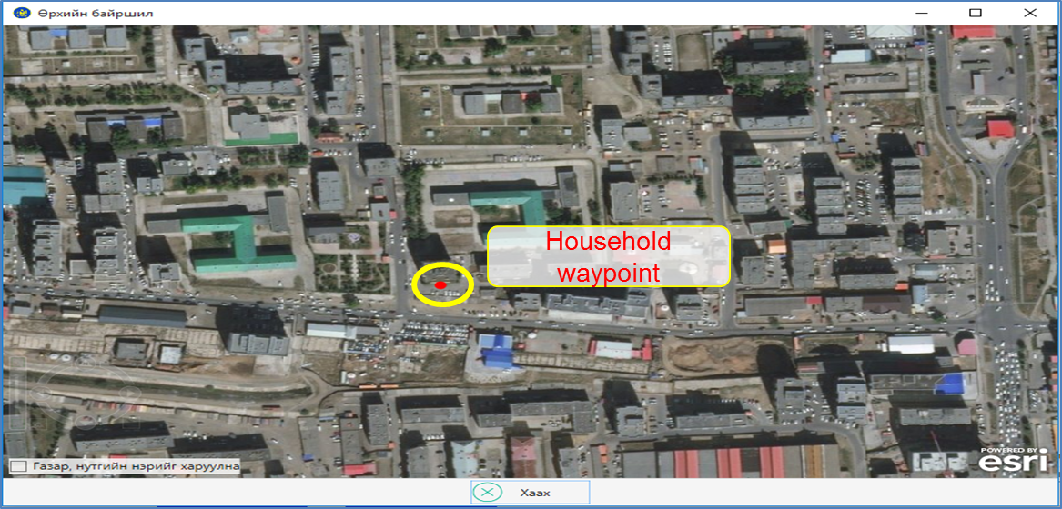
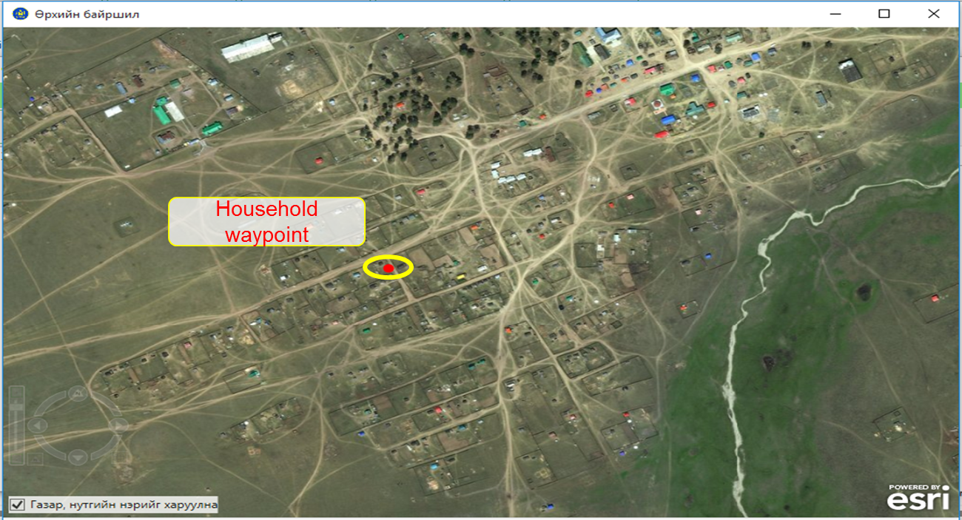
In the Population and Household Register Database, each household is assigned with a unique ID number that stays with the household when moved to a different place. With this feature, lifetime migration can be captured and analyzed which was otherwise possible based on decennial census results only.
Incorporation of household ID number into the Agricultural Census enabled further use of the geospatial statistical database. Linkage between household register and livestock census can produce interesting and useful information.
Figure 6. Use of geospatial statistical database for informed decision making
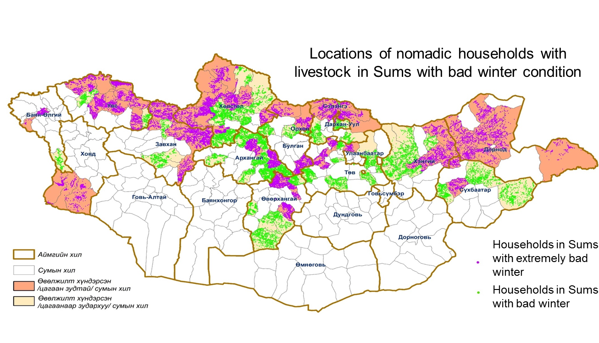
DEVELOPMENT OF GEOSPATIAL FRAMEWORK IN MONGOLIA
National Geospatial Infrastructure
Under the Ministry of Construction and Urban Development, the Administration of Land Affairs, Geodesy and Cartography Agency is the central government organization responsible for delineating the country’s territory, geographical coordinates and altitudes, as well as implementing the state policy by developing national geospatial infrastructure and providing the public with services and information other than classified by the state.
The Development of National Geospatial Infrastructure was first initiated in 2004 by the Administration of Land Affairs, Geodesy and Cartography Agency and has been state endorsed since 2008. High level Working Group headed by the Prime Minister was established in 2013, constituting from all major government organizations.
The project is still under its development and substantial amounts of achievements has been done with supports from international organizations and partner agencies. However, establishment of its legal basis and related documents and standards are still yet to come.
Integrated Urban Development Geospatial Database of the Capital city Ulaanbaatar
Apart from the development of the National Geospatial Infrastructure, the Capital city of Ulaanbaatar has been working on its own creation of state of the art Integrated Urban Development Geospatial Database. The project involves geospatial data integration from 7 different agencies of the Capital city Governor’s Office and enable linkage of 33 agencies to access the database with different settings of viewing, editing, uploading and downloading the data.
Figure 7. Visualizations on the Integrated Urban Development Geospatial Database
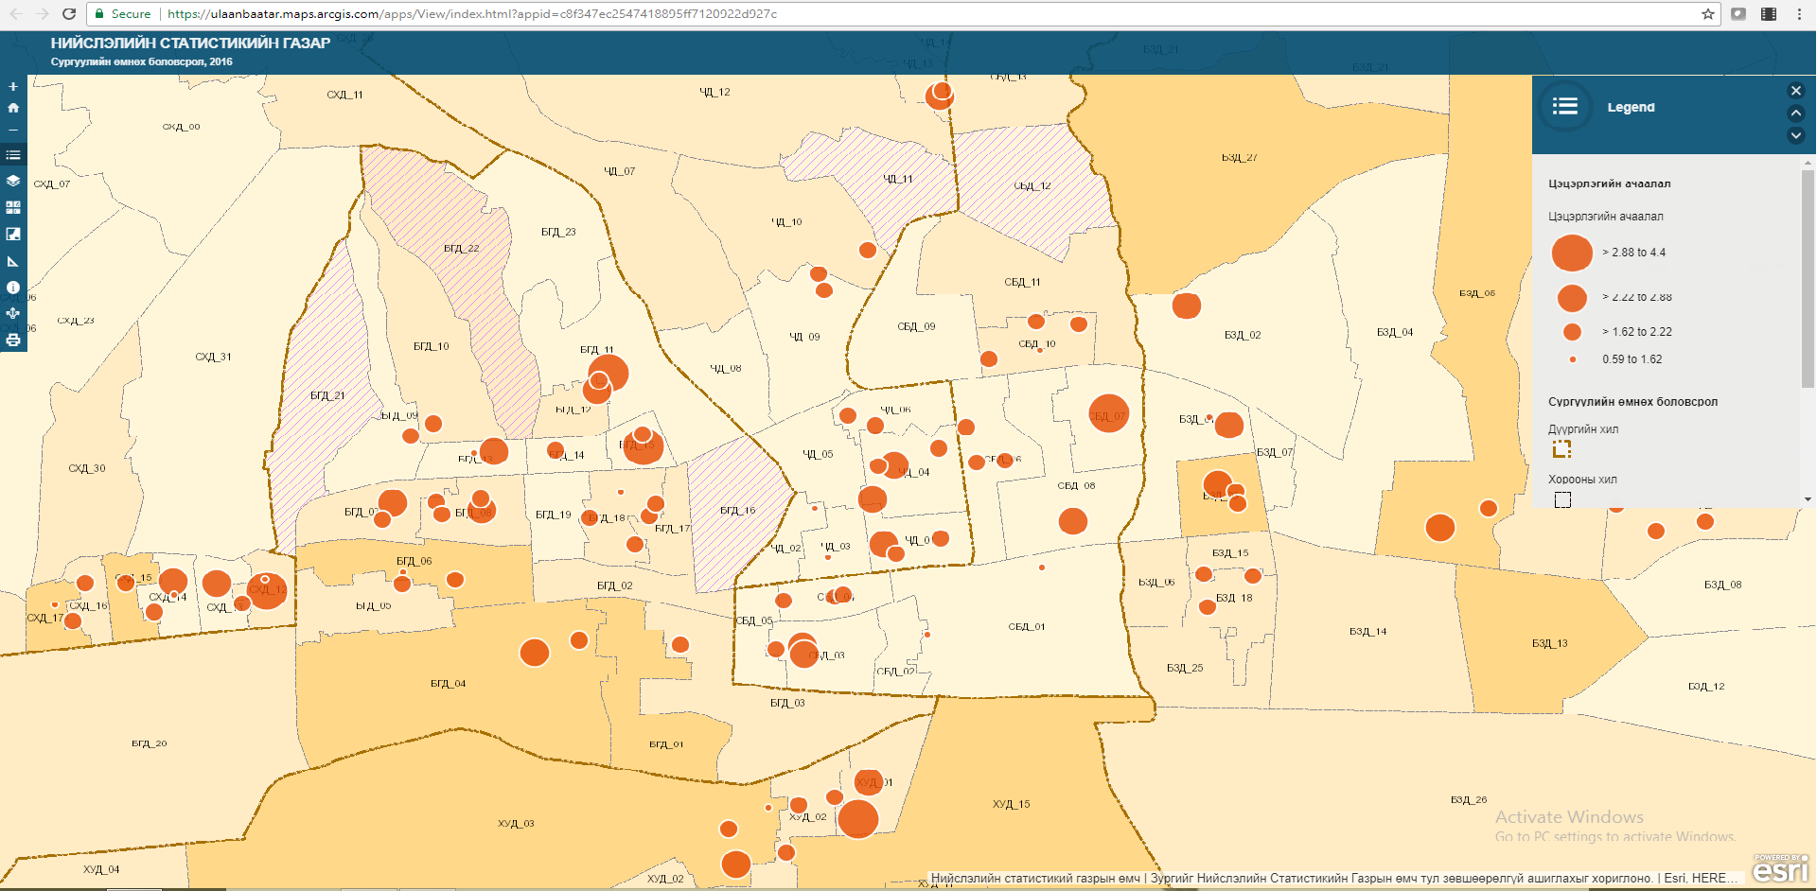
Major contributors of air pollution in Ulaanbaatar
Distributions of kindergartens in Ulaanbaatar and their workloads
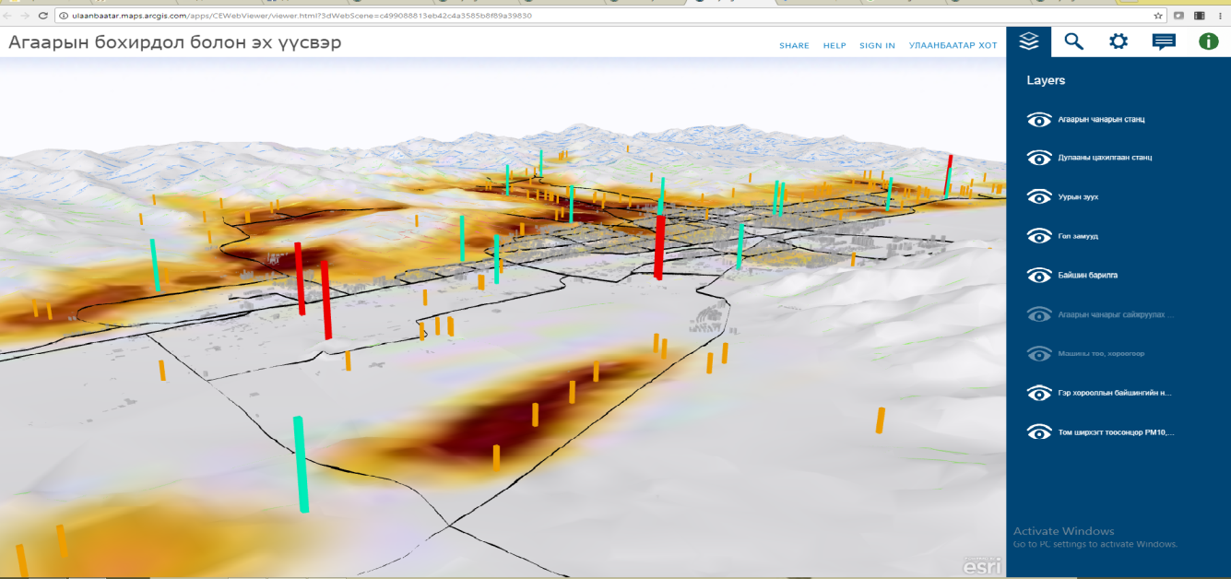
THE 2020 POPULATION AND HOUSING CENSUS OF MONGOLIA
In accordance with the Law on Population and Housing Census, the next decennial census is scheduled to be conducted in 2020. The NSO Mongolia is planning to employ a multi-modal approach using register-based census method complimented with traditional field enumeration.
Figure 8. Data collection plan for the 2020 Population and Housing Census
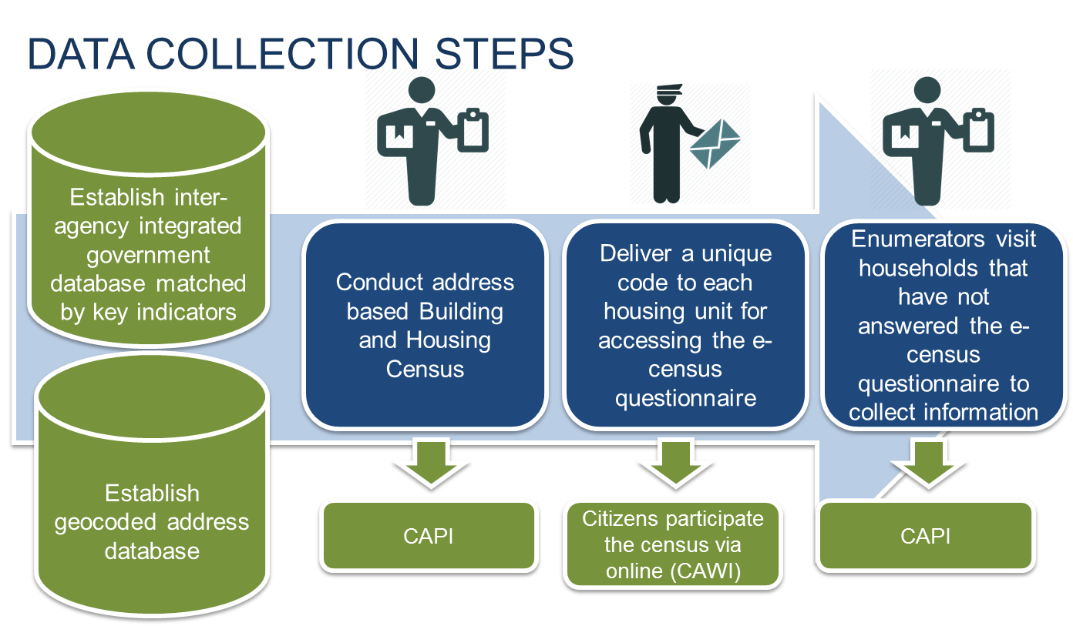

Building and Housing Census
In preparation for the 2020 Population and Housing Census, address based Building and Housing Census is planned. It is to be conducted independently for the first time to fully identify the complete housing funds regardless of its occupancy before the decennial census. Previous population and housing censuses enumerated household occupied housing units only for their housing conditions based on indicators of the core topics recommended by the UN. In order to establish the complete framework for the 2020 Population and Housing Census, the Building and Housing Census is scheduled to be conducted in 2019 upon implementing some key innovations. Activities include:
- Evaluation of existing geospatial database for building and housing
- Establishment of statistical units
- Establishment of geocoded address database
Evaluation of existing geospatial database for building and housing units involves extensive cooperation with relevant government agencies and other public service providers, such as electricity and heating companies. As a central organization for urban planning, the Master Planning Agency of the Capital city of Ulaanbaatar develops and maintains database of buildings and constructions that require approval of State Construction Commission, such as high rise apartment complexes or commercial buildings. Databases established at other agencies and companies include the Real estate registration database, electricity and heating supply company databases.
Figure 9. Availability of geospatial data from different sources
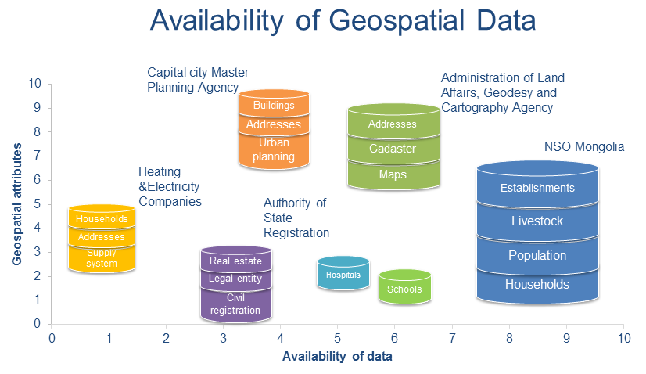
Establishment of statistical units
Since the 2010 Population and Housing Census, total of 65 sub-district level administrative units were newly created, including 45 new Bags in provinces and 20 new Khoroos in the Capital city. New administrative units can be created, taken down or merged together by the Order of the Governor of superior level at any time and creates inconsistencies in statistical dynamics. Furthermore, delineation of the sub-district level administrative unit boundaries are not officially established and causes confusions between different databases.
NSO Mongolia realizes the importance of establishing statistical units, an area boundary that are independent from administrative unit boundaries. It should consist of different levels as the census blocks being the smallest area units. Benefits of establishing statistical units include:
- Consistency of socio-economic statistical dynamics in geographical areas
- Better sampling frame
- Accurate estimation of small area statistics and others
For the 2010 Population and Housing Census, the country territory was divided into over 12000 enumeration areas. The delineation of enumeration areas was based on the number of households in rural areas and the number of population in urban areas. Enumeration area boundaries were not digitized during the 2010 census, however, the method of digitizing the household waypoints can indicate rough delineation, if the 2010 census enumeration area should serve as the base.
Aimag Sum/District Bag/Khoroo EA HH#
Household waypoints: 21 34 53 01 001

Establishment of geocoded address database
Address system and database in Mongolia is very rough. It has been one of the major concerns over the last decade and has been reflected in action plans of several government turns. Transformation or improvement of the nationwide address system is a comprehensive exercise beyond the mandate and capacity of the NSO Mongolia. However, with support and cooperation within government organizations, development of a geocoded address database is highly sought after.
Since the enactment of the Law on Addresses in 2013, new standards and guidelines have been developed.
Conclusion
NSO Mongolia is putting great efforts on improving the efficient utilization of geographic information system in every aspect of statistical activities. Incorporating geospatial information, such as household and business establishment waypoints into censuses created possibilities to better improve its geospatial statistical database and enabled visualization and dissemination of more effective statistical products for informed decision making. Use of satellite imagery in the Population and Household Register Database for geo-referencing household locations has been a cost-saving mission while the database is highly regarded by local administrative officers as a key tool for statistical and administrative purposes. As the national interest on geospatial development has been rising, NSO Mongolia is taking its parts for the improvement of its existing geospatial statistical framework.

References:
- Statistical Yearbook of 2016, National Statistical Office of Mongolia, Ulaanbaatar, 2017
- National Report of the 2010 Population and Housing Census of Mongolia, Ulaanbaatar, 2011
- Main Report of the 2015 Population and Housing by-Census, Ulaanbaatar, 2016
- Introduction of National Geospatial Infrastructure, E.Bayarmaa, G.Jargal, S.Enkhtuya, Administration of Land Affairs, Geodesy and Cartography Agency, Ulaanbaatar, 2013
- Integrated urban development geospatial database, http://ulaanbaatar.maps.arcgis.com/home/index.html
- www.worldatlas.com

www.worldatlas.com

