Addressing the issue of missing or non-ideal sampling frames in household surveys in developing countries through remote sensing data

Abstract:
Household surveys are the most important data source on the socio-economic conditions of the population living in Low- (LIC) and Middle-Income (MIC) countries. In most cases the surveys are design based probabilities surveys requiring a sampling frame. However, in many cases, the existing frames do not fulfill the basic requirements of an ideal frame, namely completeness, currentness and informativeness. Surveys based on an inadequate sampling frame may deliver imprecise or biased estimates. Since any information related to sampling errors is based on this frame, the errors related to inadequate sampling frames usually remain undiscovered. The problem of inadequate sampling frame is quite common. High Income Countries (HIC) have an abundance of administrative data to address these problems. However, LIC and MIC countries most likely do not have sufficient high quality administrative data and therefore exclusively rely on their decennial census. To address this considerable limitation, we compare a sample drawn from a census based sampling frame to samples using stratification from satellite data including landcover, gridded population data or share of built-up area for a single province in Malawi. We show that the deviation between the estimates and the true value are within the expected interval for all designs and frames, and that the sampling frame data derived from satellite data, performs either as good, or in some cases even outperforms the pure census-based frame results. Our research therefore provides evidence to support the use of satellite data in the construction of household sampling frames either in combination with census data or even as a stand-alone solution.

Keywords: Sampling Methods, census
JEL: C83

- Introduction
Household surveys are the most important data source on the socio-economic conditions of the population living in Low- (LIC) and Middle-Income (MIC) countries. And in most cases these surveys are design-based probability surveys. One important prerequisite for this type of surveys is a sampling frame.
However, in many cases, these frames do not fulfill the basic requirements of an ideal sampling frame, namely completeness, currentness and informativeness. Surveys based on an inadequate sampling frame may deliver imprecise or biased estimates. Since any information related to sampling errors is based on this frame, the errors related to inadequate sampling frames usually remain undiscovered.
The problem of inadequate sampling frame is quite common, even in High Income Countries (HIC). But where the latter commonly has an abundance of administrative data to address these problems, LIC and MIC countries most likely don’t have this fallback option, since the quality of their administrative data is not sufficient so far. For this reason, the latter group of countries very often relies on the information collected once every 10 years.
To overcome this considerable drawback, we propose the use of remote sensing data as auxiliary information in the sampling frame. To further address the issue of non-available sampling frames, we will also us this type of data as a substitute for the census data.

- Conventional Sampling Frames and Designs

  - Sampling Frames
For an ideal sampling frame, the following three criteria need to hold:
- It must be complete, i.e. cover each sampling unit in the target population once and only once.
- It must be current, i.e. the frame data must cover the target population as present during the survey period.
- It must be reasonably informative, i.e. contain information which can be used to make the sampling design more efficient.
Whereas a violation of criteria iii. mainly results in higher sample sizes, criteria i. and ii. can have severe consequences. The resulting error very often constitute the largest share in the overall non-sampling error.
Sampling frames used in household and population surveys are commonly based on a country’s housing- and population census, which are conducted every 5 or 10 years. In a Census every individual in the population and present within the territorial boundaries of the country during the census period is enumerated, and some basic demographic data is collected. Whereas in many HICs, the data is converted to a list frame, in LICs and MICs this data is compiled as an area frame. The reason for this is that the latter group of countries very often lacks adequate administrative and address systems, which would render it difficult to maintain a list frame, as well as pose certain challenges to the survey logistics.
Figure 1 gives a quick overview on the relation between target population, the frame population and the final sample. The longer the census lags behind, the more the overlap of the different groups decreases, and the more the quality deteriorates. Since LICs and MICs are confronted with high population dynamics, it is very likely that these deviations are significant shortly after the census.
Figure 1: From the Target Population to the final sample
Sample
Non-Respondents
Respondents
Frame Population
Target Population

Violation of the three criteria stated above are common for all countries which use a census based sampling frame. However, whereas the group of HICs can rely on a sufficient stock of auxiliary information to address these violations, mostly derived from administrative data, LICs and MICs lack this kind of remedy.
Some countries conduct demographic surveys to update their sampling frames, though in many cases with limited usability (i.e. insufficient sample size, badly linked to the census data, inadequate demographic projection method). In the group of countries with the strongest need for high quality household survey data – the most impoverished ones – these surveys are very often not carried out at all, due to a lack of funds.
This puts statistical agencies (and every other institution) conducting surveys in these countries in a very unfavorable position and provides unreasonable confidence in the resulting estimates, since any quality metrics related to data based on these sampling frames is misleading, as they do not consider this potentially large source of (non-sampling) error.
Nevertheless, many statistical agencies nowadays conduct their census by also collecting geo-referenced information either on the location of the households or at least on the location of the census delimitation areas, which in most cases constitute a sampling unit in the standard stratified multi-stage designs. Availability of this type of auxiliary information allows for the allocation of sampling units in space, and the application of other geo-referenced data sources.
Most of this georeferenced data comes from high resolution satellite imageries and is freely available in the public domain (i.e. ESA, 2016). Using satellite imagery data has already a long-standing tradition in agricultural surveys (i.e. Carfagna et al., 2015), but its application in household survey is rather scarce. Some recent examples are
In the following we will use this data, to
- Update the sampling frame to improve currentness and coverage
- Add auxiliary information to increase informativeness
In addition, we will also address the issue of inexistent or inaccessible sampling frames by sampling exclusively from an imagery based sampling frame. For the latter purpose we will have two different types of data sources, namely a high resolution raster image of built-up area (30 m resolution) and currently only available for some countries, as well as a high resolution raster image (100 m resolution) of gridded population estimates, available for all countries, and fully in the public domain. A more detailed description of these data set will be provided bellow.
  - Sampling Design
The most common designs in household surveys are stratified multistage designs, with some or all the stages sampled by Probability Proportional to (estimated) Size (PPS).
Given the limited amount of information available in the census data, stratification is commonly done by the classification of the area the household resides in (i.e. urban/rural) and/or the corresponding administrative unit (i.e. provinces). The latter however constitutes a sampling domain with a desired degree of precision in many cases. For both cases though, the main aim of stratification is to achieve representability, and not necessarily to minimize the estimator variance. Since a higher degree of stratification reduces the variance of the resulting estimates by creating (variance) homogenous groups within the strata (Neyman, household surveys which don’t or can’t consider this option usually require higher sample sizes than otherwise. Resulting surveys therefore require higher budgets and subsequently are conducted less frequently (Kilic et al., 2017). Besides this, larger sample sizes may also lead to larger non-sampling errors (Thompson, 2012).
Within the stratum, sampling units are sampled by PPS at some or even all of the sampling stages. Main reason for PPS sampling is that the variance of the weights is lower than in a Simple Random Sample (SRS) and that the resulting estimates are epsem or self-weighting if proportional stratum allocation was chosen. However, this requires the (estimated) Measure of Size (MOS) to be correct in the first place.
Another important attribute of the MOS to provide unbiased estimates is its proportionality to the variable of interest (Cochran, 1977). In standard household surveys this is usually the size of the sampling unit. Given this condition holds, this design gives an unbiased estimate of the population total $\hat{Y}$.
$$\hat{Y}= \sum_{i=1}^{n}{\frac{1}{p_{design}}Y_{i}}$$
Figure 2 demonstrates the effect of an incorrect measure of size applied to the estimation of the total population, derived from a sampling simulation described in more detail below. Resulting estimates for the population size from each of the simulation runs give the distribution bellow. One important characteristic of a sampling distribution for an unbiased estimate is its center around the true population mean. The graphical argument is further supported by the percentage deviation of the estimate from its true value, commonly referred to as the (relative) Root Mean Squared Error (RMSE) and calculated as:

$$RMSE=\frac{\sum_{sim=1}^{1000}{{RMSE}_{sim}}}{1000}=\left[\frac{1}{1000}×\frac{\sqrt{{(\hat{Y}-Y)}^{2}}}{Y}\right]×100$$

Figure .. below compares the sampling distribution of an incorrect MOS with a correct MOS, as well as the corresponding RMSE. Whereas the distribution on the left-hand side is much closer to the population mean, since it applies the correct MOS, the right hand side distribution is fairly wide spread out. Correspondingly the RMSE increases from 1.43 % to 10.93 % which is almost a tenfold increase. By transforming Equation .. we can also calculate the increase in the confidence interval, which can be written as,

Since the population total is not necessarily the most important estimate in household surveys conducted in these countries, Figure 4 also shows the simulation results for aggregate household consumption, which is normally used to calculate the poverty rate. The resulting increase in the RMSE is almost 70% (0.52, to 0.89). An enlargement of this size leads to the situation that i.e. the comparison of poverty rates between periods only has sufficient power if the rate of change is high enough. Smaller changes are therefore not significantly measurable.
Such estimates would be substantially misleading, and eventually result in a wrong evidence base for public policies, as well as for the corresponding resource allocation. Given that this issue does not pertain to a few exceptions, but rather constitutes the standard situation, we have to ask how much more can go wrong.
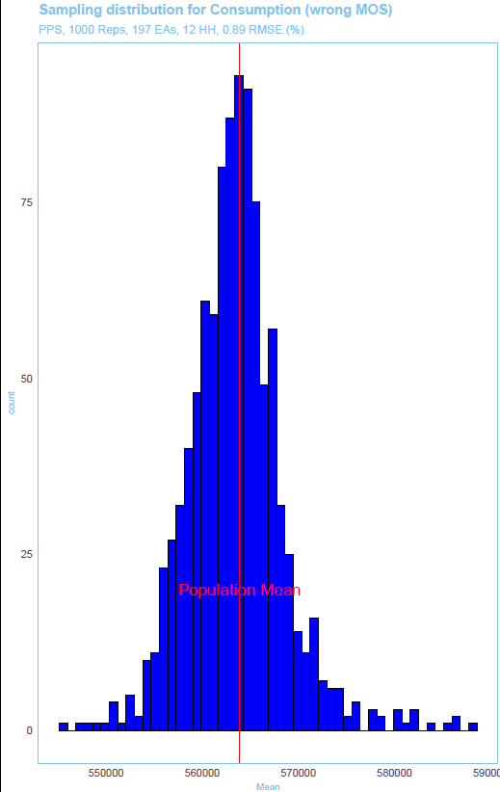

Though this decrease in precision would be undiscovered, since in a standard survey setting, the true value of our variable of interest is not known and the precision is based on the applied frame, and written as:

$$MSE\left(\hat{Y}\right)=E{\left(\hat{Y}-Y\right)}^{2}=E{\left[\left(\hat{Y}-\tilde{Y}\right)+\left(\tilde{Y}-Y\right)\right]}^{2}=E{(\hat{Y}- \tilde{Y})}^{2}+2E\left(\hat{Y}-\tilde{Y}\right)\left(\tilde{Y}-Y\right)+{\left(\tilde{Y}-Y\right)}^{2}$$
$$Var\left(\hat{Y}\right)+Bias(\hat{Y})$$

with $\hat{Y}$, $\tilde{Y}$ and $Y$ being the estimate from the sample, the mean of this estimate and the true value in the population respectively. Var is the corresponding variance, and Bias the resulting bias component, which is defined as:
$$Bias \left(\tilde{Y}\right)= \tilde{Y}-Y$$
If the mean of the estimator and the population mean is the same, the bias is 0. And the MSE would be equal to the variance of the estimate, which is only a result of the sample size. However, in a real survey situation, the population mean is commonly unknown, the resulting MSE therefore captures both, the variance and the bias. Since a sampling frame which is not covering the target population well, is likely to produce a different mean for the variable of interest than its true population mean, we may expect the bias to be different from 0.
A collateral of the results in Figures 3 and 4 is the fact, that in multipurpose household surveys not all variables benefit equally from a PPS design. The stronger however the relationship between the MOS and the target variable is, the larger will be the improvement by applying PPS, given that the MOS is correct.

- Methodology

  - Simulation and Frame
To compare the efficiency of the different sampling frames and designs, we will apply an empirical sampling simulation. In this type of (Monte-Carlo style) simulation, either a true or synthetic population is used as the target population. By applying a specific sampling design, and repeated sampling (usually 1000 repetitions) under this design, we can compare the resulting population estimates with the known true population values for each run of the simulation.
The resulting distribution of these estimates is called the sampling distribution, and the average squared deviation from the underlying population value is the Mean Squared Error (MSE) or when taking its square root, the Root MSE (RMSE). To facilitate the comparison, we use the relative version expressed in percentage deviation.
Empirical sampling simulations can be considered as the “[…] ultimate tool for investigators who want to know if one sampling strategy will work better than another for their population.” (Thompson, 2013). However, this requires the underlying simulation population to replicate as realistically as possible the target population.
The target variables chosen were collected during the last census. We have chosen variables of sufficient quality as well of different types (i.e. continuous vs. ratio) and with different proportionality to the MOS.
With the simulation set up in this way, we conducted the following experiments and compared the resulting estimates with each other:
i) Sampling from a conventional sampling frame stratified, by the available census variables. This is the baseline scenario, and the commonly applied approach for this type of survey. As mentioned at the outset, this approach depends very much on the quality and, in particular, the timeliness of the sampling frame, which unfortunately is often not satisfactorily fulfilled.
ii) Sampling from a purely satellite based sampling frame, where the population values are derived from an index of the built-up area. In this scenario, we test the possibility of sampling only from a grid that measures the values of the built-up area within the grid cell. This approach would allow a sample to be taken entirely without the help of the census-based sampling frame.
iii) Linking of the satellite-based population data as well as the land coverage data to the available georeferenced census-based enumeration areas (hybrid approach). The primary purpose of this approach is to update the conventional sampling frame to reflect the required timeliness discussed above, as well as to improve its informativeness by adding the landcover data. This allows us to conduct a higher degree of stratification, resulting in a more balanced distribution of the target variable(s) population variance.
  - Population Estimates
Population means and totals are estimated from the sample population with the support of design weights. Design weights are the inverse of the selection probability of the final sampling unit.
The final estimate is already described above, however the selection probability in a 2-stage design can be decomposed in 2 components, one for each sampling stage:
$$p_{design}= p_{1}*p_{2}=\frac{m}{M}*\frac{n}{N_{M}}$$
for random selection at both stages, and:
$$p_{design}= p_{1}+p_{2}=\frac{{m*MOS}_{m}}{\sum_{m=1}^{M}{{MOS}_{m}}}*\frac{n}{N_{M}}$$
if ${MOS}_{m}=N_{m}$ equation .. becomes:
$$p_{design}= p_{1}+p_{2}=\frac{{m*N}_{m}}{\sum_{m=1}^{M}{N_{m}}}*\frac{n}{N_{M}}$$

for pps selection at the first stage and random selection at the second stage when household cluster size constitutes the measure of size. A design as this one is called epsm. Each unit has an equal chance of selection and resulting population estimates have a lower variance as. However due to non-response this result hardly holds in practice. For this purpose design weights commonly undergo some post-survey non-response adjustment. One such approach is the calibration of weights to some known population totals as described in the next section.

  - Sample calibration
A standard procedure in post-survey adjustments is weight calibration, such that the weights match known to population totals. These totals can either be derived from the sampling frame or from other sources, like population register. or demographic projections. The resulting calibration estimator is defined as follows:
Whereas ratio adjustment or raking only allows for one or two simultaneous calibration targets at the same time, calibration estimators as described in Särndal and Lundström (2005) allow for the simultaneous calibration of several target variables.
Assuming a linear relationship, the calibrated weights would be derived as:
$$w_{i}^{c}= w_{i}+w_{i}λ_{r}x_{k}$$
Where $x_{k}$ is a vector of sample and population information, and $λ_{r}$ is and adjustment factor such that
$$\sum_{r}{w_{i}^{c}x_{k}}=X$$
With $X$ being a vector of know population totals. Main properties of this adjustment are the correction for non-response, as well as a decrease in the variance of the estimate.

  - Design Effect

Design effects need to be considered when dealing with clustered sample populations. It defines the homogeneity within the clusters in comparison to the variance between clusters and is defined as:

$$d=1+ρ(n-1)$$
Where $ρ$ is the corresponding intra-cluster correlation (ICC). If the ICC is 0, which is the case in a pure random sample, d=1, however it is usually positive and therefore d>1. Sample sizes need to be adjusted for this value either by providing larger sample sizes or by calculating the final effective sample size.

- Data
The whole analysis is based on 3 different exclusive datasets for Malawi as well as two publicly available data sets. The first data set consists of the 2011 Housing- and Population Census data, which provides key demographics and some auxiliary information for each of the 951,375 persons enumerated during the census. Each person belongs to a household, and each household to a PSU.
The second data set are the georeferenced area boundaries for each of the 800 PSUs. A common PSU code allows us to identify the contained households.
The third we use comes from satellite imagery and is a raster image of built-up area in a 30m resolution. In addition to this, we will use auxiliary information for land coverage from the publicly and free of charge accessible CCI Land Cover project, based on Sentinel 2-A data (ESA Climate Change Initiative, 2017) at a 500m resolution.
Without loss of generality and for computational reasons, we have limited the simulation to a single province in Malawi, namely Blantyre. All descriptive statistics presented in the following therefore refer to this single province.

  - The census data
This is the original census data as provide by the statistical agency, and which is commonly used as the basis for the area sampling frames used by statistical agencies in the absence of any reliable list frame. It is conducted once every 10 years, and in the case of the underlying data set, not demographic adjustments have been carried out. It contains information on every individual enumerated during the last census round. However, this data does not contain any geo referenced information, besides the enumeration area containing the household and described below.
Table 1 gives the main characteristics of this dataset, as well as for the variables of interest used in our simulation.

    - Household Consumption
Total household consumption was not directly observed and had to be estimated through a two-stage mixed-effect model derived from recent survey data. A linear mixed model was chosen since it allows us to preserve within cluster variance. The model is specified as follows:

$${consumption}_{ij}=β_{0}+β_{1}{size}_{ij}+σ_{j}+ϵ_{ij}$$
With ${consumption}_{ij}$ being the consumption of household i in cluster j and ${size}_{ij}$ being the number of individuals in the same. $σ_{j}$ is a cluster specific random effect, and $ϵ_{ij}$ is the usual random error.

  - The geo-referenced PSUs
The geo-referenced PSU’s are from the Malawi in partnership with the Living Standards and Measurement Study at the World Bank. There are approximately 12,600 polygons in Malawi with a mean area of 7.6km² and a standard deviation of 35.0.

  - The raster of built-up area.
Our dataset of built-up area is from Facebook Connectivity Labs that is an input to the High Resolution Settlement Layer (Tiecke et al. 2017). The data are at 1x1 arcsecond resolution (~30 meter). The authors also provided a validation of building localization with household survey data in Malawi, where they find an incidence of 1.7 percent at the national-level of Malawian households at a distance of more than 100m from the nearest populated (or built) pixel.

  - Allocation of SSUs in space
Since some of the simulations we run require the spatial coordinates of the individual household for comparison, we had to allocate the units in space.
We developed an algorithm, which allocates the sampling units in space according to the distribution of built-up area provided by a geo-referenced raster image described above. It does this furthermore within each of the PSUs, and therefore preserves the properties of each of them. Figure 4 shows this process.
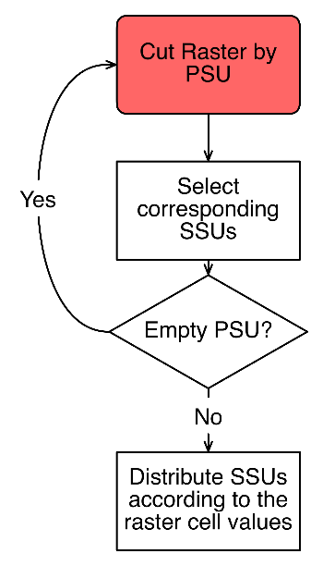
Figure 2: Construction of the simulation population

Preserving the properties of the pre-last sampling stage’s sampling units, is sufficient for the simulation population to be as close to reality as possible, since it even preserves the existing within and between PSU variance, which is important to replicate the design effects. We then run n repetitions by sampling from the simulation population under the sampling design of interest. In other words, we repeat the survey n times. For each of the 1000 simulation runs we produce weighted estimates of the target variable, as well as important quality metrics like the coefficient of variation, the true MSE, its Standard Errors as well as its Design Effect.
Figure 3 shows a sample of allocated households as described in figure 2 for an urban PSU as well as for a rural PSU.

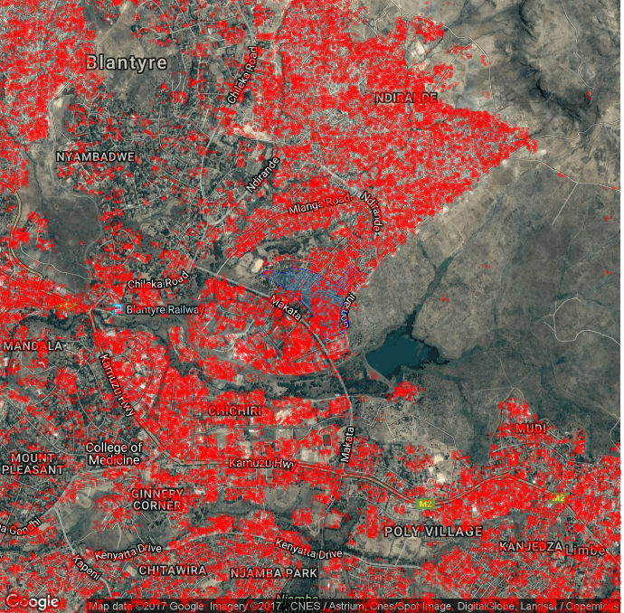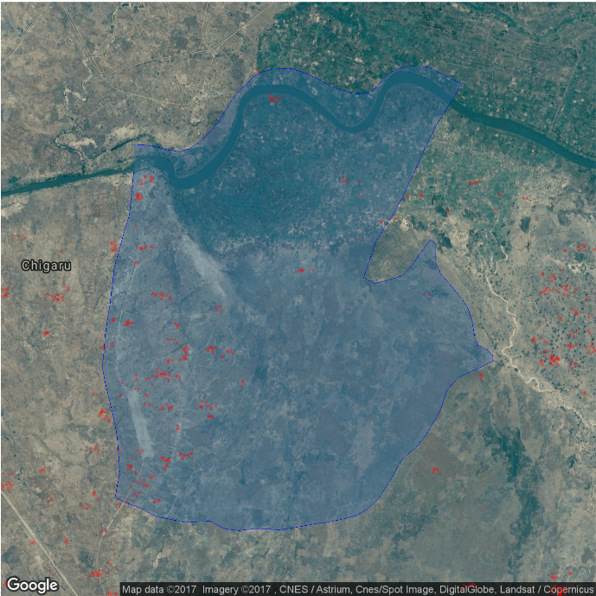

  - Publicly available data
Besides the proprietary data sets described above we have also used data sets which had been freely available in the public domain.
    - ESA landcover
One dataset available in the public domain is a newly released high resolution raster dataset (20 m resolution) produced by the European Space Agency with its Sentinel 2A satellite. The data used for the production of the final map pertains to the period of December 2015 to December 2016.
The Coordinate Reference System used for the global land cover database is a geographic coordinate system (GCS) based on the World Geodetic System 84 (WGS84) reference ellipsoid. The classification algorithm used Random Forest and Machine Learning and 10 classes were eventually identified. Table .. bellow shows these classes.
NB_LAB | LCCOwnLabel | R | G | B
0 | No data | 0 | 0 | 0
1 | Tree cover areas | 0 | 160 | 0
2 | Shrubs cover areas | 150 | 100 | 0
3 | Grassland | 255 | 180 | 0
4 | Cropland | 255 | 255 | 100
5 | Vegetation aquatic or regularly flooded | 0 | 220 | 130
6 | Lichens Mosses / Sparse vegetation | 255 | 235 | 175
7 | Bare areas | 255 | 245 | 215
8 | Built up areas | 195 | 20 | 0
9 | Snow and/or Ice | 255 | 255 | 255
10 | Open Water | 0 | 70 | 200

Given that the available resolution is 20 m, this data set can also be applied for aggregation at the level of very small sampling units. It may therefore also provide the possibility to be used as an MOS in surveys where i.e. a particular landcover type is important and strongly related to the variable of interest, but since our sampling frame does not contain any landcover relate information, we did not pursue this track further.
The land cover data set used in this study is only one example of earth surface data, available in the public domain. But survey objectives may differ and it is therefore worth to check if a different survey objective may benefit from a different type of data. ESA’s Sentinel as well as NASA’s Landsat satellites produce more and more highly granular data and available in a fairly user-friendly format. In this way even non geo-experts can add this information to their data.

    - WorldPop
Is a data set of gridded population values with a spatial resolution of 0.000833 decimal degrees (approx. 100 m). The population data is distributed through a Random Forest based model, as described in Stevens (2015). Data was calibrated to the 2008 population totals.

- Results
One limitation of the results is related to different time periods in which the data was collected. Whereas the census was conducted in 2011, the satellite imagery comes from 2015 (built up area) and 2016 (land cover). This however only renders the results more prudent, since the estimates derived from or with the support of satellite imagery would subsequently give a more accurate picture, since it would reflect the correct distribution of the target population.
  - Sampling from a conventional sampling frame stratified, by the available census variables.
To address the problem of a lack of informativeness in the sampling frame, we will in a first step add the above described landcover types contained in a raster image to the sampling frame at the level of the PSU. In this way we can demonstrate, that already by adding this widely available type of data, we can substantially improve the estimates. One important perquisite for an improvement of the estimates through stratification is a sufficiently strong relationship between the variable(s) of interest and the stratification variable. In the case of the landcover, we decided to estimate the number of housing types. The landcover aggregation at the PSU level was done by calculating the share of crop area (category 4 in Table ..).
To make the most out of the additional information we also used a newly developed allocation algorithm, which optimizes stratification by simultaneously creating and allocating strata, such that the overall variance of the estimate is minimized at a prespecified level for each domain of interest. This algorithm is implemented in R by using the package samplingstrata (Barcaroli, 2014).
We will first compare a sample drawn in the conventional way from the census data frame, with a sample making use of the additional stratification. Results are presented in Table .. below.
Table 1: Census based Approach
Incorrect size measures have also been used as MOS to demonstrate the impact on the different estimates. The bigger the relationship with the target value, the larger is the impact of size on the MSE (in percent).
Stratification has been applied by different variables as described in the appendix.

  - Sampling from a purely satellite based sampling frame, where the population values are derived from a raster of gridded population data.
There are situations, where there is no frame at all. In this case the option exist to use gridded population data. In our simulation we have used WorldPop, and results are shown bellow.
Table 2: Worldpop only sample

  - Linking of the satellite-based population data as well as the land coverage data to the available georeferenced census-based enumeration areas (hybrid approach)
In this section we apply an option, which allows to draw a sample from a combination of geo-referenced enumeration areas and different remotely sensed data.
This situation arises, when either the census data is expected to be severely outdated, or when only the geo-referenced units but no other census data is accessible. We have produced the same population estimates, by either a pure PPS (PPS) design or a stratified PPS (STRPPS) and with or without calibration to known population totals. Calibration has been implemented at the household level, which preserves equal weights for all household members.
The MOS was the ratio of built-up area to the total EA’s area. To further improve the estimates, the sample includes an additional stratification, by built-up area into 3 strata, and sampling units are proportionally allocated. Table .. bellow presents the results of this.

Table 3: Hybrid frame

Results are largely comparable, however for the population count the MSE is considerably larger. Other estimates compare quite well in terms of their MSE and their CV. As expected estimates can be further improved through logistic calibration, with the accompanying decrease in the CV.
Which, however, becomes particularly clear in view of the results is the improvements of the results derived by this MOS over the results derived from an incorrect MOS. In other words the application of recent satellite data should be preferred over the option of outdated population data.
It is also important to note in this regard, that the built-up area is derived from images which took place a few years after the original census, and since we only spatially allocated the units within the enumeration area, but not between them, our estimates are rather conservative, and the improvement over any wrong MOS as well as the difference between the census and the satellite based MOS will most likely develop further in favor of the latter MOS.
As an additional comparison we have also created an MOS from the 2010 WorldPop dataset, and results are shown in .. bellow.
- Conclusions
Our research successfully demonstrated the use of remote sensing data to improve multi-purpose household surveys. In particular when the sampling frame is not accessible or severely outdated, the creation of a sampling frame from remotely sensed data of built-up area or gridded population data may pose a serious alternative and allows for estimates with an acceptable degree of precision. However remote sensing data may also add additional information to the sampling frame, which allows for a more efficient stratification.
With the increase in publicly available satellite date with a high degree of detail we may most likely also see an increase in applications of this approach.
Processing of the data could be done with standard open-source software, however the paper is also accompanied by a cloud application which supports the herein discussed approaches through a GUI.

References:
Barcaroli, G., 2014. SamplingStrata: An R package for the optimization of stratified sampling. Journal of Statistical Software, 61(4), pp.1-24.
Carfagna, Elisabetta, and F. Javier Gallego. "Using remote sensing for agricultural statistics." International Statistical Review 73, no. 3 (2005): 389-404.
Cochran, W.G., 1977. Sampling Techniques: 3d Ed. Wiley.
ESA Climate Change Initiative, 2017, Land Cover project, viewed 22 January 2018, http://2016africalandcover20m.esrin.esa.int
Friedl, Mark A., Damien Sulla-Menashe, Bin Tan, Annemarie Schneider, Navin Ramankutty, Adam Sibley, and Xiaoman Huang. "MODIS Collection 5 global land cover: Algorithm refinements and characterization of new datasets." Remote sensing of Environment 114, no. 1 (2010): 168-182.
Jerven, M. (2013). Poor Numbers: How We Are Misled by African Development Statistics and What to Do About It. Cornell Univ. Press.
Kilic, T., Serajuddin, U., Uematsu, H. and Yoshida, N., 2017. Costing household surveys for monitoring progress toward ending extreme poverty and boosting shared prosperity.
Särndal, C.E. and Lundström, S., 2005. Estimation in surveys with nonresponse. John Wiley & Sons.
Singh, R., Goyal, R.C., Saha, S.K. and Chhikara, R.S., 1992. Use of satellite spectral data in crop yield estimation surveys. International Journal of Remote Sensing, 13(14), pp.2583-2592.
Stevens, F.R., Gaughan, A.E., Linard, C. and Tatem, A.J., 2015. Disaggregating census data for population mapping using random forests with remotely-sensed and ancillary data. PloS one, 10(2), p.e0107042.
Tiecke, T.G., Liu, X., Zhang, A., Gros, A., Li, N., Yetman, G., Kilic, T., Murray, S., Blankespoor, B., Prydz, E.B. and Dang, H.A.H., 2017. Mapping the world population one building at a time. arXiv preprint arXiv:1712.05839.
Thompson, S.K., 2012. Sample size. Sampling, Third Edition.
United Nations. Statistical Division, 2008. Designing household survey samples: practical guidelines (Vol. 98). United Nations Publications.

The authors thank the participants of Gridded Cluster Survey workshop organized with Vince Seaman at the Bill and Melinda Gates Foundation in Seattle, U.S. in May 2018, and the participants in the Boundaries, Buildings, and ’Burbs: Foundational Geospatial Data to Support Sustainable Development, GeoHealth, Hazard, and Climate Applications session organized by the POPGRID Data Collaborative at the American Geophysical Union Annual Meeting in Washington, D.C. December 2018. We appreciate the support of our institution and financing from DFID under the World Bank’s Strategic Research Program ‘Big Data’
Variance minimization may still be the case, since urban and rural populations are most likely more homogenous on most of the variables of interest within the respective stratum than between.
To reduce the computational burden, the analysis is carried out for a single province only, namely Blantyre (city and rural area). All numbers presented in the following refer to this province. Furthermore, the data has been cleaned from incomplete or implausible cases, so the values may also not precisely match the official numbers as published by the Government of Malawi.
For more details please see: http://2016africalandcover20m.esrin.esa.int/ for more information. © Contains modified Copernicus data (2015/2016) © ESA Climate Change Initiative - Land Cover project 2017
https://land.copernicus.eu/global/products/lc
https://landsat.usgs.gov/
WorldPop (www.worldpop.org - School of Geography and Environmental Science, University of Southampton). 2017. Malawi 100m Population. Version 2.0 estimates for numbers of people per grid cell for 2000, 2010, 2015 and 2020, with national totals adjusted to match UN population division estimates (http://esa.un.org/wpp/), and remaining unadjusted. Note, an additional dataset is included for the census year, on which 2000, 2010, 2015 and 2020 estimates are based. DOI: 10.5258/SOTON/WP00538

