UN HLG MOS Executive Board Meeting 22/02/22 - Update on Machine Learning

ML Group 2022 Programme Launch
The Machine Learning Group started a new stage of its work for 2022. The ambitions for this year are stepping up international research collaboration and capability building, and exploring the challenges of putting ML applications into production.

The programme was launched in early February following a call for activity proposals open to all members of the official statistics community. Proposals for study groups and research projects on specific themes were presented at a meeting of the group on February 9th with all members invited to sign up to participate. (There is still time for colleagues to participate – please take a look at the programme information here and contact ML2022@ons.gov.uk if you would like to join any activity).
The programme was developed by grouping together proposals with similar themes where there was most alignment with our purpose as well as potential for collaboration with the wider group.
As in previous years, coding and classification is the most popular topic. There’s greater interest in topics such as modelling, model retraining and imagery. We also have some important proposals in cross-cutting areas important for production such as algorithm quality and digital infrastructure.
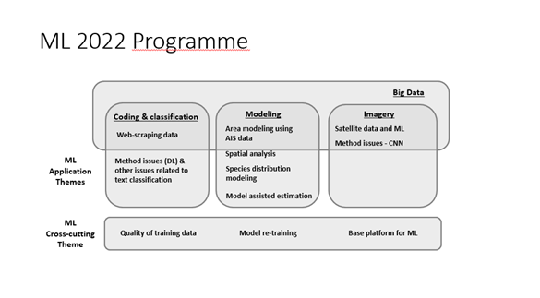

These themes indicate that coding and classification is still viewed as the most useful application of machine learning for official statistics. The greater prominence of topics such as modelling, model retraining and imagery also show that the community has reached a greater level of maturity in machine learning.

We have some substantial research projects that will involve active collaboration between different NSOs as part of our Global Data Squad.

Interest in machine learning is increasing within the official statistics community. The group has recruited over 40 new members since the start of the year, including from new countries including Rwanda, Zimbabwe, Qatar and Pakistan. Around 140 people joined us for the programme launch, roughly half of whom were new members, and another half returning.

ML 2022 at UN Big Data Conference @ Expo Dubai.

The Group ran a number of sessions at the UN Big Data Conference at the World Expo in Dubai last month.

- We promoted the work of our ML Group at a session introducing the value of machine learning for national statistical offices. This included presentations of ML Group work from Arie Wahyu Wijayanto from Statistics Indonesia (satellite imagery), Dominik Dabrowski from Statistics Poland (text classification) and Claus Sthamer from UK ONS (editing).
- We also delivered a number of technical training sessions and a workshop on how to approach the operational challenges of implementing an ML model.

You can view the public session videos here. This was our first in-person conference since the Covid pandemic and it was really valuable to be able to hold discussions in person again. We made a lot of new connections with the data science community in the Middle East and also with the UN Regional Hubs and UN Task Teams of the UN CEBD. We plan to build on these connections by working more closely with the Task Teams and supporting the Regional Hubs in our activity programme this year.

Next steps
- Theme activities (research projects, knowledge exchange groups) to begin work in next few weeks
- Half-way reporting expected July
- In person expert meeting planned for November
Request for input
- Idea to hold in-person expert meeting for ML in Official Statistics –
  - Benefit: Can accelerate progress on key issues
  - Timing: 31 Oct-2 Nov in Geneva OR on sidelines of HLG MOS workshop
  - Request: Feedback on idea – and any NSO interested in hosting?

- Machine Learning Journey of a National Statistical Office – looking for volunteers from NSOs to speak to the ONS ML Group about their organisation’s experience of exploring and using ML. 15-20 minutes – ideally a representative with a strategic overview of data science activities across their organisation.

- Please promote the ML 2022 activity programme in your organisations – still time for colleagues to get involved with our work this year, View the website here https://statswiki.unece.org/display/ML/Machine+Learning+Group+2022 and contact ML2022@ons.gov.uk for more information.

