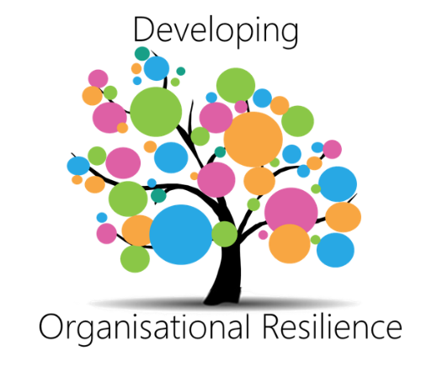

Visions, Missions and Target Operating Models
How National Statistical Organisations are developing their understanding of the future

Introduction

Organisations develop strategy to ensure they understand WHAT they are aiming to achieve over time, and HOW they will go about achieving this.

National Statistical Organisations (NSOs) across the world operate in an increasingly complex environment. The opportunities of the digital, technology and data revolutions, and dramatic shifts in the global economy, society and politics, are providing an unprecedented opportunity to fundamentally re-define the purpose of a statistical organisation for the modern age.

It is through strategic adaptability, the ability to handle changing circumstances, which organizations can prepare for external shocks. Through their systems, structures, people, processes, products and values, organisations can adapt quickly and prosper in challenging environments.

It is in this context that NSOs today are considering their strategy for the future. This includes their overall mission/vision and what they will look and feel like once it is achieved – their Target Operating Model.

Many of the challenges and opportunities faced by statistical organisations are common, even when they vary in terms of scale or specific context. The Developing Organisational Resilience Modernisation Group collected a number of examples of NSOs visions, mission statements and target operating models. This paper seeks to provide an overview of the various strategic approaches, to foster learning and guide the broader community of NSOs.

Vision and Mission Statements in NSOs

Mission: A written declaration of an organisation's core purpose and focus that normally remains unchanged over time.

Vision: An aspirational description of what an organisation would like to achieve or accomplish in the mid-term or long-term future.
www.businessdictonary.com

NSOs use mission and vision statements interchangeably and depending on specific needs. It is therefore reasonable to consider them together as broad statements of strategy.

Based on a sample of NSOs, the word cloud below shows the key words which appear in these mission and vision statements.

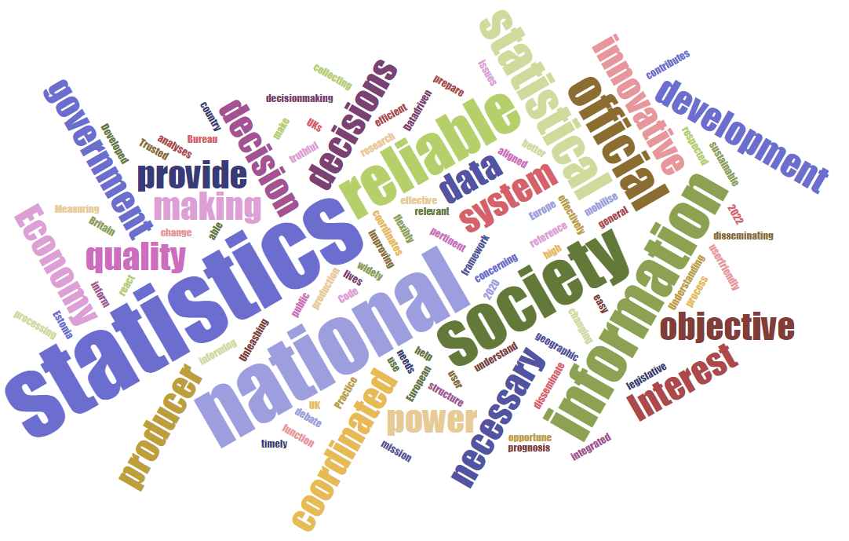
It is clear there are several common themes coming through in these statements, and therefore common choices NSOs are making as to their future.

Becoming data driven organisations: Many NSOs are focussing their strategy on data, either seeking to develop into a ‘data hub’ to service the needs of (mainly government) stakeholders or through the increased use of data in statistics and analysis. New Zealand, for example, highlight this in their vision statement: “Unleashing the power of data to change lives.” Similarly, Canada uses “The Vision: A Data-driven Society and Economy”.

Focussing on decision making: Another clear focus is on how NSOs can increasingly inform decision making, and therefore lead to real outcomes for the economy and society. This is shown in the United Kingdom’s vision to “help Britain make better decisions.” It is clear that NSOs are no longer seeing their goal as to just produce statistics, they are moving more towards organisations who deliver through their impact and their relationships, not just through producing statistics.

Seeking to innovate: The sense of pace and change comes through in many of the strategies, for example Estonia’s vision to become “the most effective and innovative producer of reliable and user-friendly statistics in Europe.” This resonates with the need for organisations to keep pace with rapid changes in technology and data, and potential competition from other data and information organisations. France’s mission includes “Innovating and being at the forefront with data sources”.

Maintaining the core values of an NSO: Whilst there is clearly a focus on moving to a new state, NSOs still maintain core values in their strategies for the future. This includes the need to be objective, trusted and reliable. For example, Mexico aim to “provide society and government with quality, pertinent, truthful and timely statistical and geographic information of national interest.” NSOs must change, must innovate, but must also recognise the core values which make them unique. This is well noted in Lithuania’s vision: “Statistics Lithuania is reliable producer of official statistics which is able to flexibly react to the changing user needs and effectively coordinates the production of the national statistics”

Strategic Frameworks
Most NSOs embed delivery of these vision and mission statements into their daily work through a strategic framework which includes developing a multi-year plan with strategic objectives linked to specific activities. An example of such a strategic framework is the Netherland’s strategic agenda.
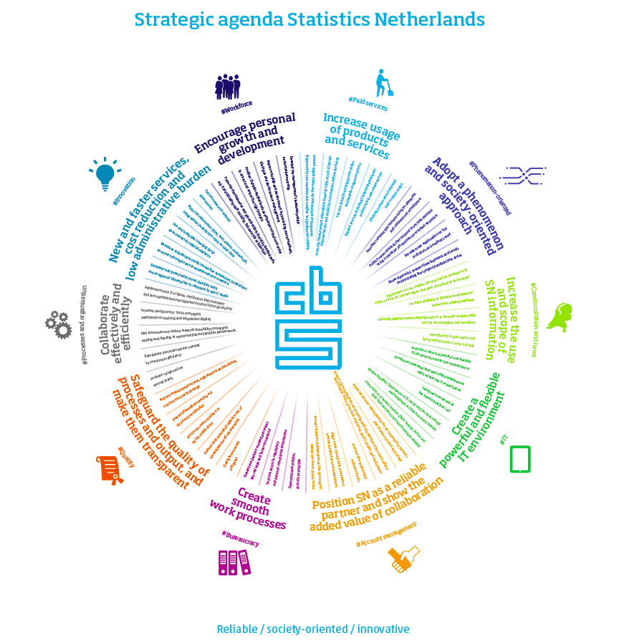

Target Operating Model Design
Another important part of making vision a reality is to develop a Target Operating Model (TOM), a description of the future state of the organisation once the vision is achieved.

Target Operating Model: a description of the desired state of the operating model of an organisation. When working on the operating model, it is normal to define the "as is" model and the "to be" model. The Target Operating Model is the "to be" model. www.wikipedia.com

Once organisations understand their vision for the future it can be useful to expand this further through development of a TOM, which describes this future state.

A TOM has several benefits including:

- To act as a framework for decision making, a guide to align decisions across areas with the strategy
- To help staff at all levels understand where the organisation is going – increases engagement with the journey
- To provide a framework against which the strategic alignment of activities can be assessed
- To support a better and shared understanding of key deliverables and help to drive out the dependencies
- To give greater clarity about who needs to deliver what when, to make a reality of the vision and secure agreement across the senior team
- To resolve any tension over which area is driving which element of change
- To describe the systems, processes, relationships and behaviours which are expected to be in operation in the future
- To support communication with external stakeholders

There are many different approaches to TOM design which can be followed, from the high-level organisation wide view to the detailed blueprint for the future across all functions and layers of the organisation.

Visual/Conceptual Models
Some NSOs who have developed their TOM by taking the approach of setting the vision for the future out in a visual way. These examples show how the organisation will look and feel in the future and how the products, processes, systems and people will change in response to changing demands.

Examples from both Norway and the United Kingdom show ‘rich picture’ designs demonstrating the flows and interactions between different parts of the organisation. Particularly around the use and flow of data and the relationships between different functions. In these examples there is a focus on:
- The creation of new, integrated, data sets, the availability of new data sources, and the transformation of data collection operations.
- Using large data sets in the production of official statistics and driving innovative analysis through a broad range of data.
- Simplifying the flow of data from acquisition, through processing to the use of data to inform decision making.
- How the production of statistics and analysis will be underpinned by increasing capacity and capability across people, processes and systems.

By using visual stories, these conceptual models simplify organisation design into a high-level view, which can be assessed simply and used as a tool for communication amongst staff and other stakeholders.

These models also act as a guiding light for decision making and to align change programmes with a clear view of the future state. Overleaf are examples from Norway and the United Kingdom.

Statistics Norway Target Operating Model:

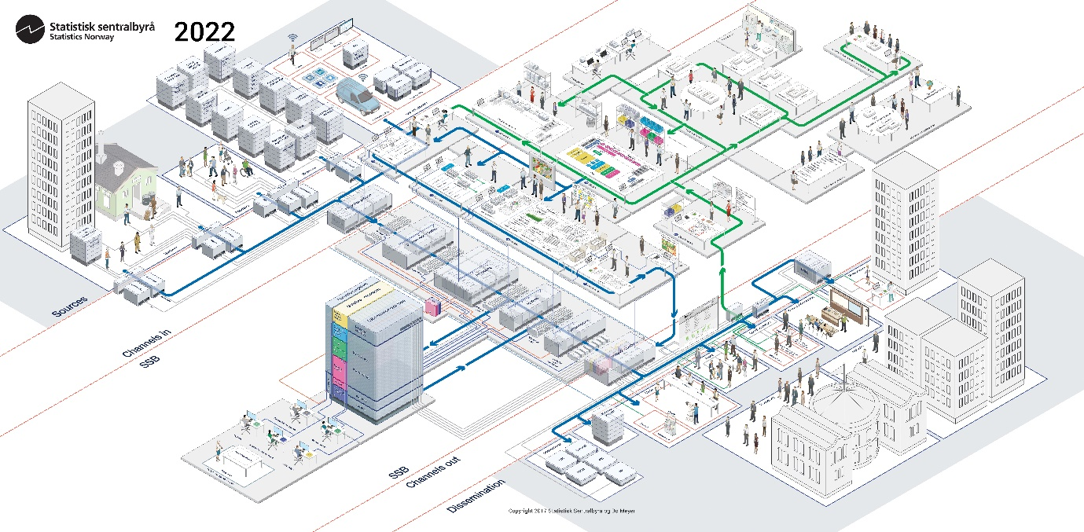

Office for National Statistics UK Target Operating Model:

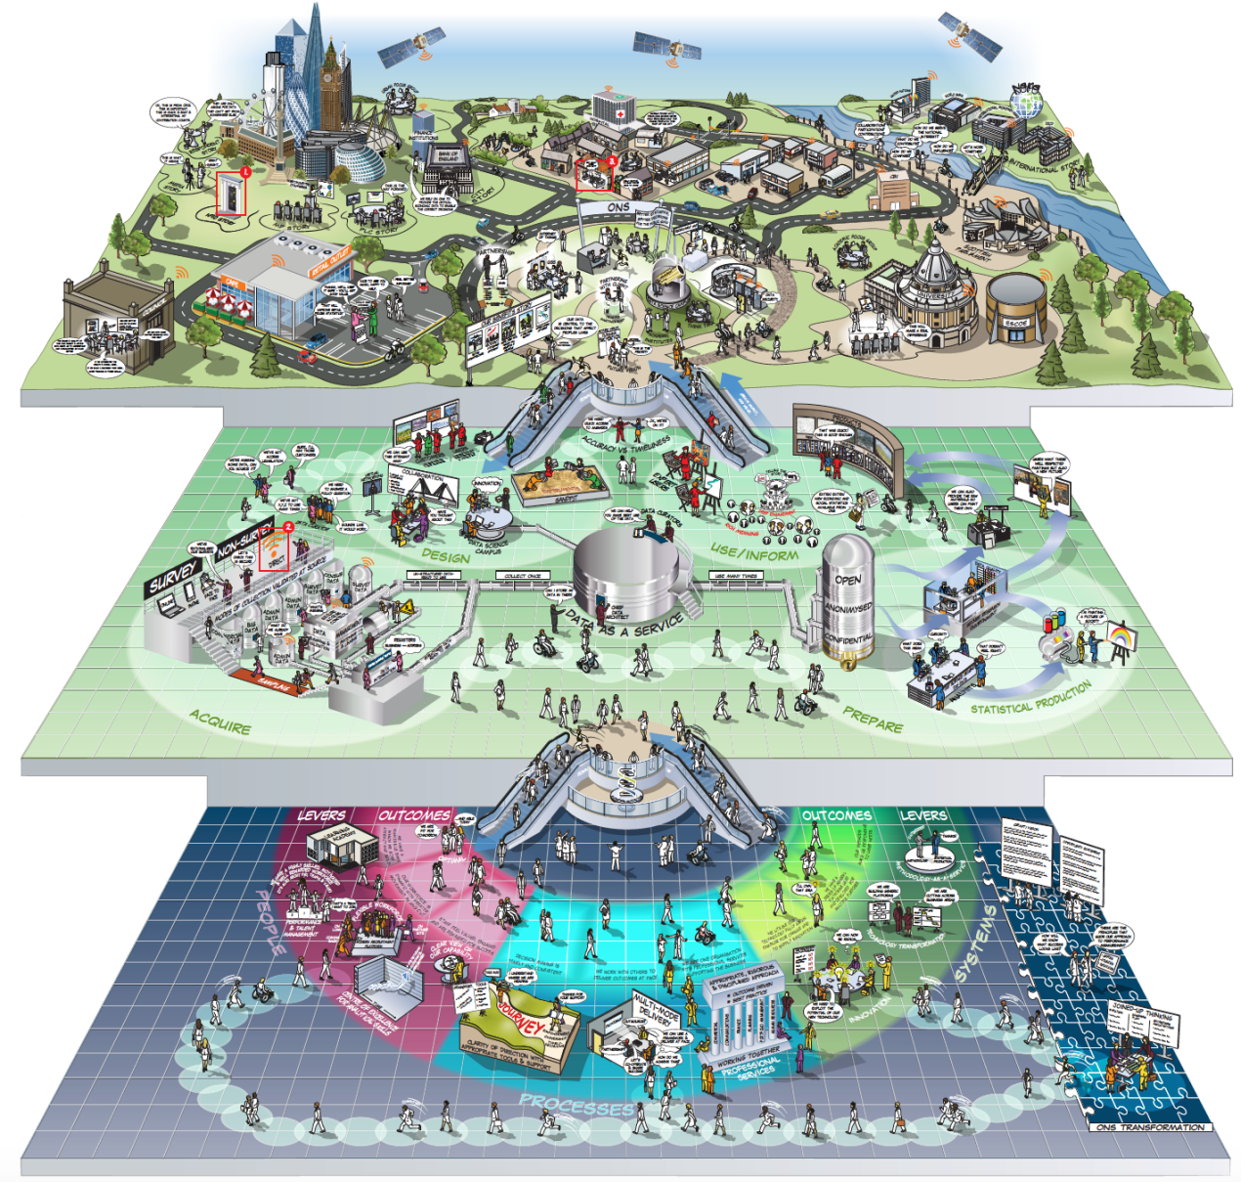

Conclusions
The HLG-MOS recognised the importance of setting a vision of a national statistical organisation as a key priority for 2019. At this point in time it is perhaps more important than ever to consider the vision for the future, given the volatile external environment and the opportunities of the digital and data revolution. In this context the visions, missions, strategies and target operating models which NSOs have developed are perhaps more ambitious, innovative and transformational than ever before.

As well as those who have developed this view of the future state many NSOs are currently engaged in this strategic thinking, for them learning others can be of great use.

Having a strong clear vision that has been communicated to staff and stakeholders is fundamental for the future resilience of NSOs. The key messages and vision must resonate with staff of all levels, users and the government. This paper gives a brief insight into what statistical organisations are currently doing in this space.

