- Check to see if the service is already available and reusable!

A primary aim of CSPA is to support efficient sharing and reuse of process patterns, information and services at an organization and international level. One key requisite in achieving this goal is an ability to reliably and efficiently discover what is available for reuse to support a particular business need. This includes an ability to efficiently assess whether a potentially reusable artefact is, in fact, "fit for purpose" in practice when in comes to supporting that particular business need.

CSPA is a reference architecture for the statistical industry. The scope of CSPA is statistical production across the processes defined by the GSBPM (i.e. it does not characterize a full enterprise architecture for a statistical organization). It is understood that statistical organizations may also have a more general Enterprise Architecture (for example an Enterprise Architecture used by all government agencies in a particular country).

The Global Artefact Catalogue fulfils this requisite - enabling the CSPA community to access and share CSPA services. It is a composite conceptual catalogue representing 5 layers of information.

CSPA is descriptive, rather than prescriptive, its focus is to support the facilitation, sharing and reuse of Statistical Services both across and within statistical organizations. CSPA is not a static reference architecture; it is designed to evolve further over time.

The Knowledge Base (Virtual Standards Helpdesk) provides access to standards such as GSIM, GSBPM and GAMSO, as well as information about DDI and SDMX.

The Investment Catalogue provides information about the developments that have been planned or are in progress by statistical organizations. User Guide: Investment and Capability Catalogues
The Capability Catalogue provides information about the developments that have been completed (ie. Capabilities that already exist) in statistical organisations. User Guide: Investment and Capability Catalogues
The CSPA Service Catalogue is hosted by Eurostat. In order to access the CSPA Service Catalogue, you will need to have established a user account with the European Commission Authentication Service (ECAS). For instructions on how to create an ECAS user account, please click here.
- If an appropriate Statistical Service is not found in the CSPA Global Artefact Catalogue, the statistical organization can either:
- start designing and developing a new Statistical Service, or
- modify an existing Statistical Service to meet new functional and/or non-functional requirements.
This could be done independently or in collaboration with other statistical organizations. This development work should be done in alignment with CSPA to ensure that the new Statistical Services can be added to the CSPA Global Artefact Catalogue for sharing and reuse by other statistical organizations.
- If you need to develop a service the logical information model (lim) should be used: (A Logical information model links the conceptual GSIM and the physical CSPA)
It is important when creating a LIM that you match the information objects and the logical relationships.
Principles of Logical Information Models
Principle 1: Change control.
Statement: LIM has change control and the following principles for designing LIM apply to every revision of LIM.
Principle 2: Backwards compatibility
Statement: LIM should provide maximum backwards compatibility.
Principle 3: Support for statistical services
Statement: LIM supports the design, development, production, maintenance and reuse of statistical services.
Principle 4: Common language
Statement: LIM provides a basis for a common understanding of information objects and the implementation of CSPA services
Principle 5: Appropriate communication
Statement: LIM must use appropriate communication for the target audience, in particular the language used in LIM must be precise and non-ambiguous.
Principle 6: Necessary level of detail
Statement: LIM contains a limited number of information objects for which the right balance between detail and abstraction should be used.
Principle 7: Robustness, adaptability and extensibility
Statement: LIM is robust, and can be easily adapted and extended to meet users' needs.
Principle 8: Optimal reuse
Statement: LIM makes optimal reuse of existing terms and definitions.
Principle 9: Platform independence
Statement: LIM does not refer to any specific IT setting or tool.

- An important concept in architecture is the "separation of concerns". For that reason, the architecture is separated into a number of "perspectives".
These "perspectives" are:
- Business Architecture which defines what the industry does and how it is done (statistics in our case),
- Information Architecture which describes the information, its flows and uses across the industry, and how that information is managed,
- Application Architecture which describes the set of practices used to select, define or design software components and their relationships, and
- Technology Architecture which describes the infrastructure technology underlying (supporting) the other architecture perspectives.
It should be noted that CSPA does not include enterprise, business, application and technology architecture descriptions which are not directly aligned to CSPA scope, nor does it prescribe technology environments of statistical organizations.

- Using CSPA will create new functional roles within a statistical organization. These roles may already exist in some statistical organizations and may have particular people (for example, Chief Information Officer, Enterprise Architect) assigned to them. CSPA makes no recommendation about who in an organization should play these roles or the composition (for example the 'investor role' could be an executive team, an investment board, or an individual business owner) – this is left to each statistical organization to decide how the role is undertaken – this is left to each statistical organization to decide who performs that role. This section and Figure 1 explain the functional roles in the form of one possible user story.
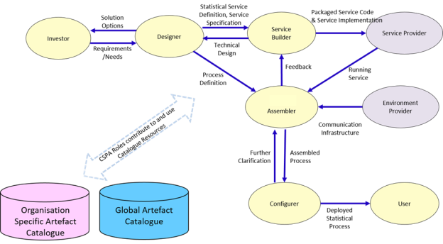
TOGAF provides the following useful definitions:
- Application - A deployed and operational IT system that supports business functions and services; for example, a payroll. Applications use data and are supported by multiple technology components but are distinct from the technology components that support the application.
- Architecture - 1. A formal description of a system, or a detailed plan of the system at component level, to guide its implementation (source: ISO/IEC 42010:2007). 2. The structure of components, their inter-relationships, and the principles and guidelines governing their design and evolution over time.
- Application Architecture - A description of the major logical grouping of capabilities that manage the data objects necessary to process the data and support the business.
- Technology Architecture - The logical software and hardware capabilities that are required to support deployment of business, data, and application services. This includes IT infrastructure, middleware, networks, communications, processing, and standards.
http://www1.unece.org/stat/platform/display/CSPA/CSPA+Implementation+Guidance

